
SkyKick Cloud Backup for Microsoft 365
Manual for Restoring

Traditional
How to do a restore of M365
Contents
1. Microsoft 365 user data and collaboration data 5
2. Restoring Microsoft 365 user data 5
3. Restoring Exchange mailbox data 5
How to access mailbox data 5
Navigate to the data you need to restore 6
Search for the data you need to restore 7
Basic search 7
Smart Search 7
Advanced Search 7
Restoring individual items 8
Restoring individual items to the latest snapshot or a specific point in time 8
Individual item restores 9
Folder restores 9
Restoring a full mailbox to the latest snapshot or a specific point in time 9
Additional restore details and scenarios 11
Restore options 11
Time to restore 11
Restoring mailbox data after a user leaves and their Microsoft 365 subscription is deleted 11
4. Restoring OneDrive for Business account data 12
How to access OneDrive for Business data 12
Navigate to the data you need to restore 13
Search for the data you need to restore 13
How to restore individual folders and files 13
Restoring individual files to the latest snapshot or a previous version 14
Restoring multiple individual items and/or folders to the latest snapshot or a specific point in time 15
Restoring a full OneDrive for Business account to the latest snapshot or a specific point in time 17
Restore Process 19
OneDrive for Business limitations that may impact Cloud Backup 19
5. Restoring Microsoft Teams chats 20
How to access Microsoft Teams chats 20
How to restore Teams chats 21
Where to find the restored Teams chat 22
How to restore files shared within a Teams chat 23
6. Restoring Microsoft Planner user tasks 23
How to access Microsoft Planner user tasks 23
Navigate to the data you need to restore 24
7. Restoring Microsoft 365 collaboration data 26
8. Restoring Exchange Public Folder data 26
How to access Public Folder data 26
Full Public Folder restore to the latest snapshot or a specific point in time 27
Individual item restore 28
9. Restoring SharePoint data 30
How to access SharePoint data 30
Search for data 31
Smart Search 31
Advanced Search 31
How to restore a full SharePoint site 31
Restoring a full SharePoint site to the latest snapshot or a specific point in time 32
How to restore individual items or folders 33
Restoring an individual file to the latest snapshot or a previous version 33
Restoring multiple items or folders to the latest snapshot or a specific point in time 34
Restore process 35
Additional details and exceptions 36
Restoring hyperlinks in a SharePoint list 36
SharePoint Site Collection in Recycle Bin 36
Customizations not supported 36
10. Restoring Microsoft 365 groups and Microsoft Teams collaboration data 37
How to access to Microsoft 365 groups and Microsoft Teams collaboration data 37
Perform a full restore by data type 38
Perform individual item restores 39
Perform a full restore of a Microsoft Team or Microsoft 365 group 40
Restoring channel posts 41
Additional details for uncommon scenarios 43
Protection of files in a SharePoint document library but not under channel Files 43
Restoring a channel within 30 days of deletion 44
Restoring private channels 44
Known issue restoring certain Teams channels 44
Unsupported Teams Data 44
Microsoft Teams (free) and Microsoft Teams Essentials 44
Microsoft Teams Break Out Rooms 45
11. Restoring Microsoft Planner collaboration data 45
How to access Microsoft Planner collaboration data 45
Restore all Planner collaboration data for a group 47
Restore one or more plans 47
Restore one or more buckets 48
Restore one or more group tasks 48

Restoring Microsoft 365 data with Cloud Backup

Microsoft 365 user data and collaboration data
In Microsoft 365, there is both user data and collaboration data. User data is owned and controlled by an individual user (e.g. their Exchange mailbox or OneDrive for Business account), whereas collaboration data is owned by and controlled by specific groups or all users (e.g. SharePoint sites and Teams channel posts and files).
Some Microsoft 365 applications include both user data and collaboration data, whereas others include strictly one or the other, as shown in the table below.
 | User data | Collaboration data
Exchange | Individual and Shared Mailboxes* | Public Folders
OneDrive for Business | OneDrive for Business account | NA
SharePoint | NA | All SharePoint data
Groups & Teams | Microsoft Teams chats | All data except Microsoft Teams chats
Microsoft Planner | User tasks | Plans, buckets, and group tasks
*While Shared Mailboxes are owned by more than one user, due to Microsoft APIs, Cloud Backup lists them within user data.
For more details, see the following sections within this document:
- Restoring Microsoft 365 user data
- Restoring Microsoft 365 collaboration data

Restoring Microsoft 365 user data
Users may have data across multiple Microsoft 365 applications. For instructions on restoring specific user data, see:
- Restoring Exchange mailbox data
- Restoring OneDrive for Business account data
- Restoring Microsoft Teams chats
- Restoring Microsoft Planner user tasks

Restoring Exchange mailbox data
Note: The process to restore Exchange user mailboxes and Shared Mailboxes is the same. For restoring Exchange Public Folders, see Restoring Exchange Public Folder data.

How to access mailbox data
If you need to restore Exchange data in an individual or shared mailbox:
- Open the subscription
- Select the Users & Groups tab
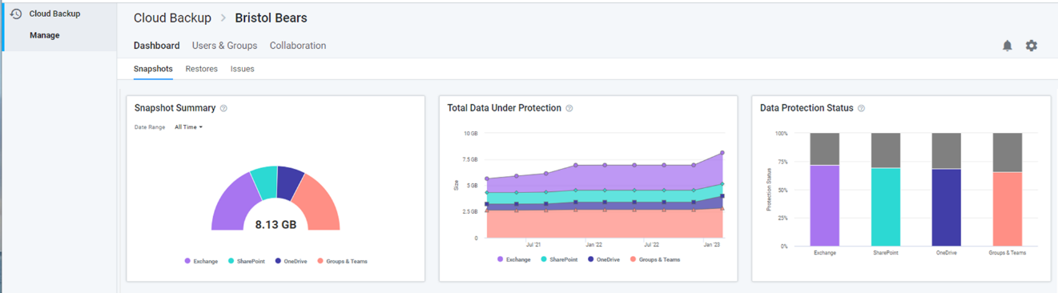
- On the Users tab, click on the user whose mailbox whose data needs to be restored
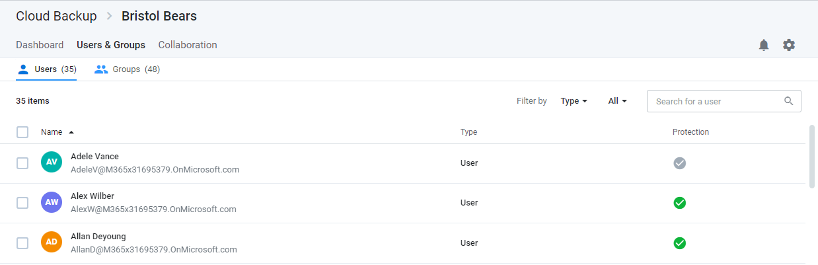
- Select Exchange in the left navigation or click the Exchange icon.
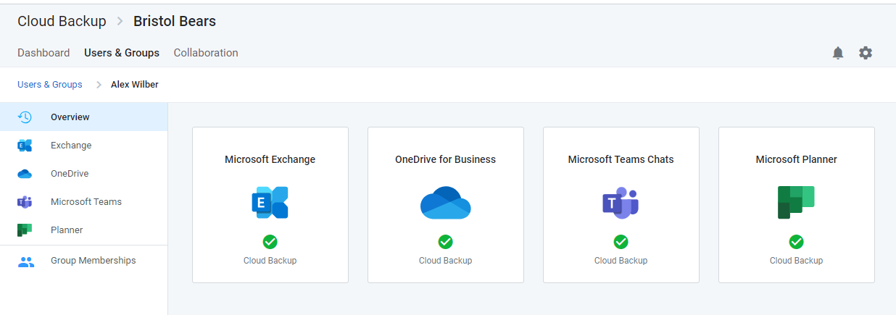

Navigate to the data you need to restore
Upon selecting Exchange, the view includes the following navigation paths:
- A Viewport on the right shows a list of files and folders you can navigate through to find the data you need.
- A Tree view on the left can be used to find a specific folder directly. This Tree view will also adjust to match the actions taken in the Viewport
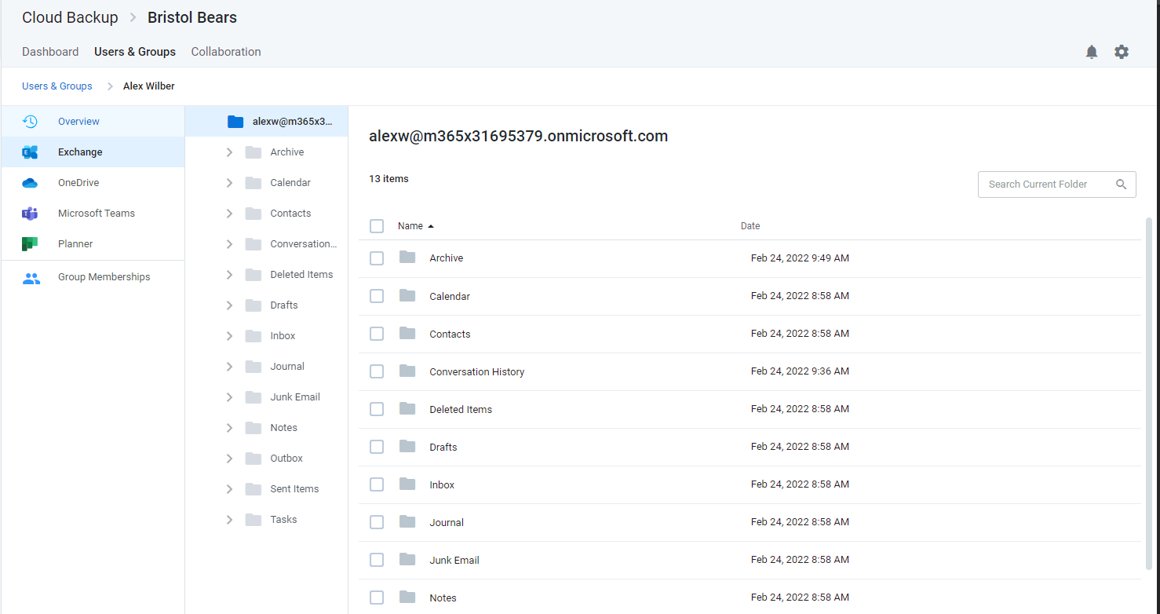

Search for the data you need to restore
Instead of or in combination with navigation, the view also includes a search field which supports a variety of search capabilities.

Basic search
Enter keywords from the header of the email or the name of the folder you are looking for. Cloud Backup searches the subject line of emails, file and folder names, contact names, and more. However, to ensure privacy, it does not search the body of emails or files.
Currently, the Cloud Backup UI has a search result limit of 500 items. Workarounds for this include the use of browsing to narrow the search within a specific folder or Smart Search.

Smart Search
Smart Search allows you to narrow a search using the following Smart Search tags.
- To:[Recipient Name]
- From:[Sender Name]
- Subject:[Subject Keyword]

Advanced Search
Cloud Backup also supports a variety of Advanced Search capabilities, including Elasticsearch, Wildcards, and RegEx.
If multiple items appear in your search, you can sort the items by Name and Date.

Restoring individual items

Restoring individual items to the latest snapshot or a specific point in time
To restore one or more individual items or folders to the latest snapshot or a specific point in time:
- Select the items
- Click the Restore button that will appear at the top of the list
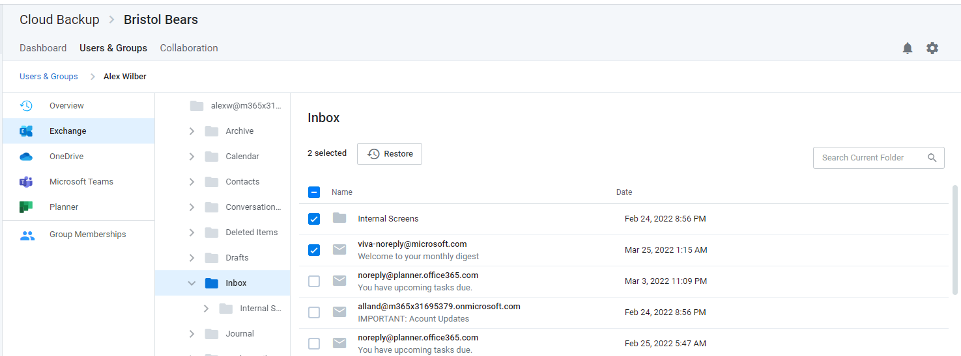
- To restore to the latest snapshot, click Validate and skip to step 7
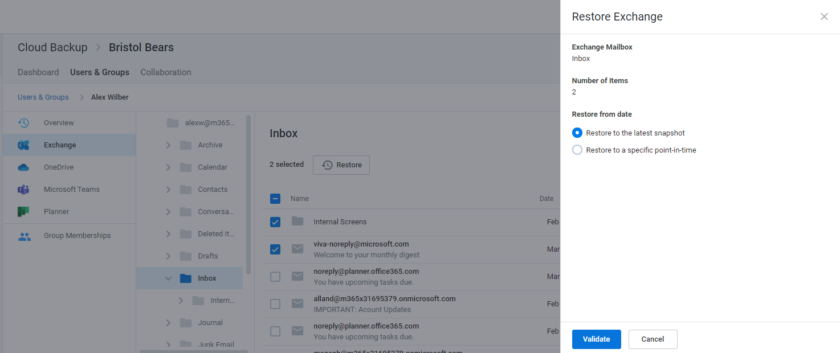
- To restore to a specific point in time, select Restore to a specific point-in-time
- Select a date and time within the available restore range
- Click Validate to initiate a series of prechecks
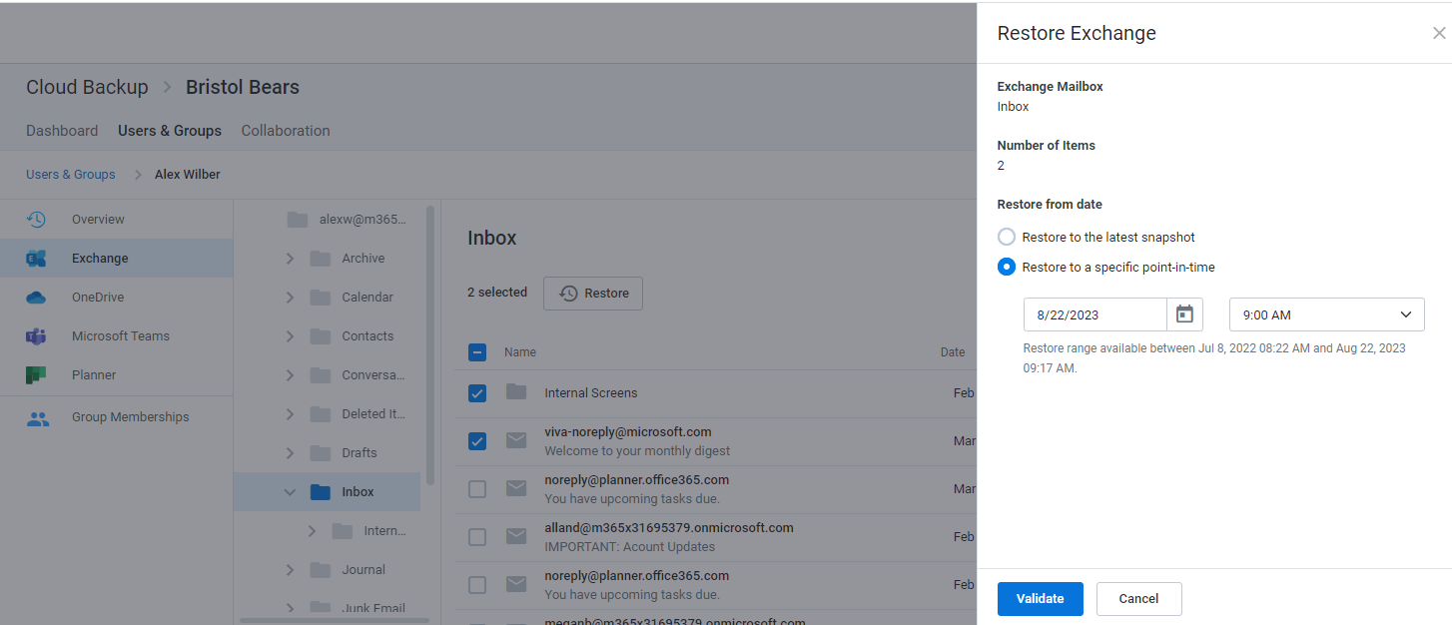
- Click Restore to proceed
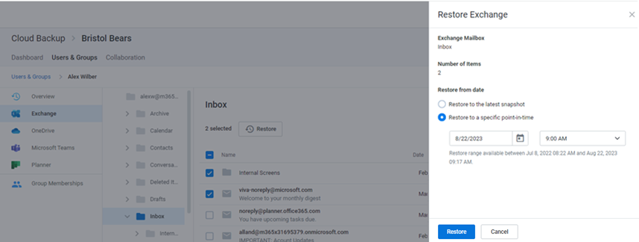

Individual item restores
When needing to restore more than 200 individual items, it is best practice to perform a bulk restore (e.g. full mailbox, folder, list, etc.) or perform multiple batches of under 200 individual restores, as extremely large batches of individual restores (e.g. over 200) may encounter issues.

Folder restores
When a folder restore is done with Cloud Backup, it is merged with existing content. In other words, the data is de-duplicated before it is inserted into the mailbox. Cloud Backup does not overwrite or delete data at any time.

Restoring a full mailbox to the latest snapshot or a specific point in time
If you need to restore an entire mailbox to the latest snapshot or to a specific point in time, check the box at the top of the list of all folders and click the Restore button.
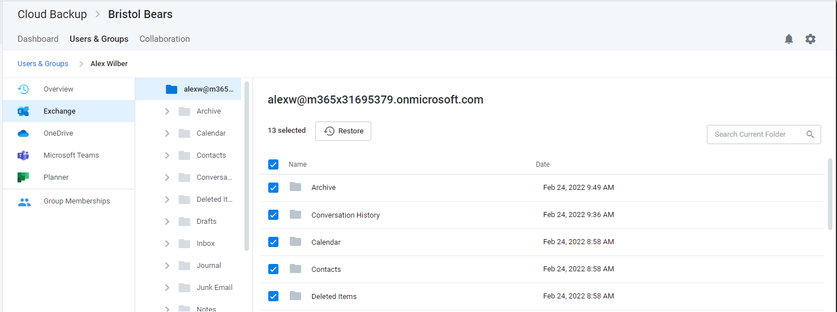

Select to either Restore to the latest snapshot or Restore to a specific point-in-time. If you choose a point in time, use the date and time fields which will appear to indicate the date and time to which you would like to restore the mailbox.
Next, click the Validate button to proceed with the restore. This will initiate a restore request validation process.
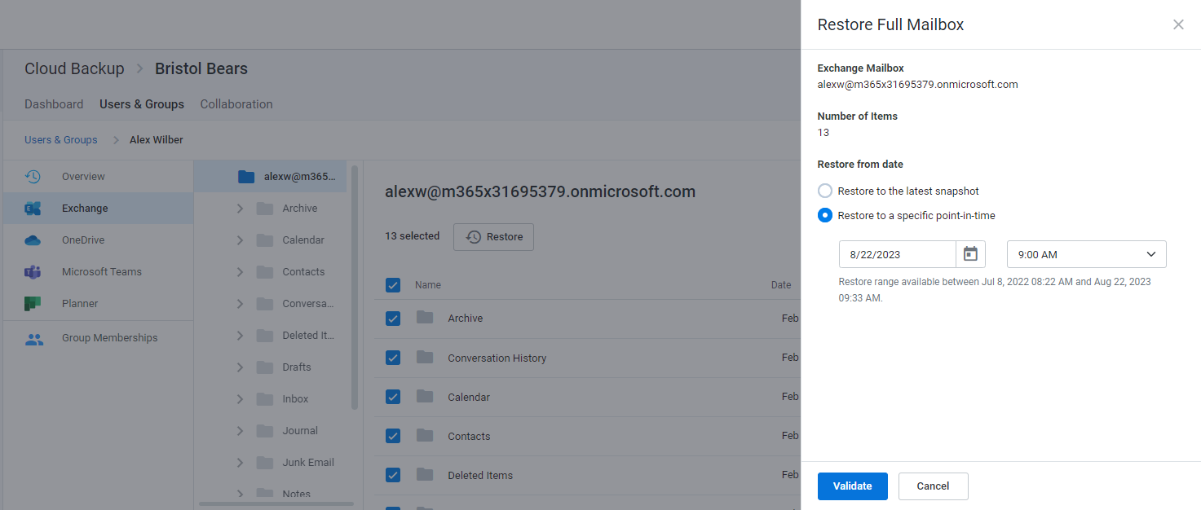
Upon success, click the Restore button to restore the mailbox.
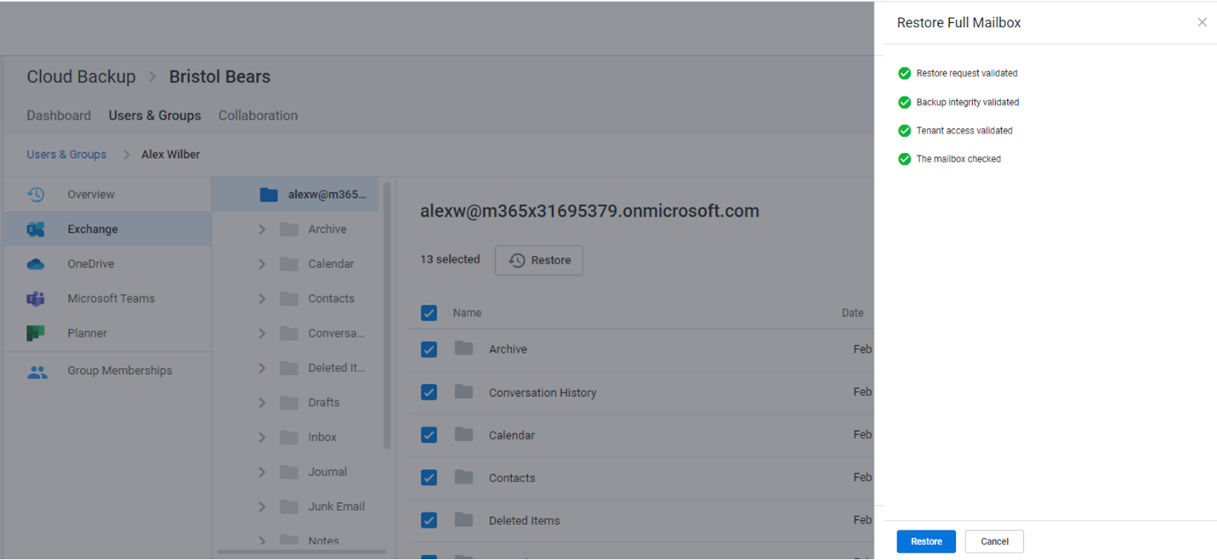

Additional restore details and scenarios

Restore options
Data | Single | Bulk/Multiple | Point-in-time
Full Mailbox | X |  | X
Email | X | X | X
Folders | X | X | X
Contacts | X | X | X
Calendars |  | X | X
Tasks |  | X | X
Notes |  | X | X
Journals |  | X | X

Time to restore
While the restore is initiated with a single click and Cloud Backup makes every effort to restore the content as quickly as possible, the time required to complete the restoration is based on a variety of external factors, including:The overall size of the data set being restored.
- Microsoft 365 throttling.
- Microsoft Azure throttling.
- The overall availability of Microsoft 365.

Restoring mailbox data after a user leaves and their Microsoft 365 subscription is deleted
As long as the subscription remains active, Cloud Backup will not delete the backup of the mailbox, and the content will be retained for the duration of the retention period (as indicated in the Settings section of an Microsoft 365 Backup subscription). If the Microsoft 365 license has been removed (thus deleting the mailbox from Microsoft 365), this will trigger an alert titled: Backup [mailbox] not found. To address this alert you will need to disable the backup for the mailbox. Once the mailbox is disabled, you will no longer be charged for the mailbox and the alert will not pop up again.
In order to maintain the integrity of the mailbox, while removing the need to have it licensed, Microsoft’s best practice is to convert the mailbox to a Shared Mailbox first, and then remove the license. By doing this, instead of simply removing the license and deleting the mailbox, no mailboxes will need to be created if the customer wants to restore the data. The backups can still be turned off for that mailbox, resulting in no further charges.
Note: Disabling the backup of a mailbox will not delete the protected data. Search and restore is available as long as the user / mailbox is protected and the subscription is active.

Restoring OneDrive for Business account data
Return to top of document

How to access OneDrive for Business data
If you need to restore data in OneDrive for Business:
- Open the subscription
- Select the Users & Groups tab
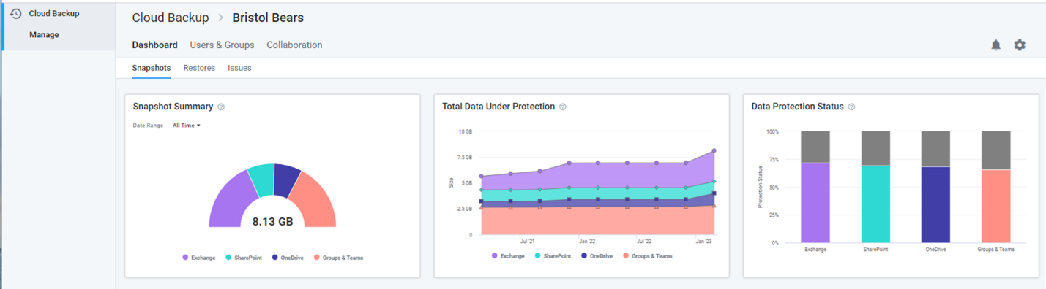
- On the Users tab, click on the user whose data needs to be restored
- Select OneDrive for Business in the left navigation or click the OneDrive for Business icon.

Navigate to the data you need to restore
Upon selecting OneDrive for Business, the view includes the following navigation paths:
- A Viewport on the right shows a list of files and folders you can navigate to find the data you need.
- A Tree view on the left can be used to find a specific folder directly. This Tree view will also adjust to match the actions taken in the Viewport
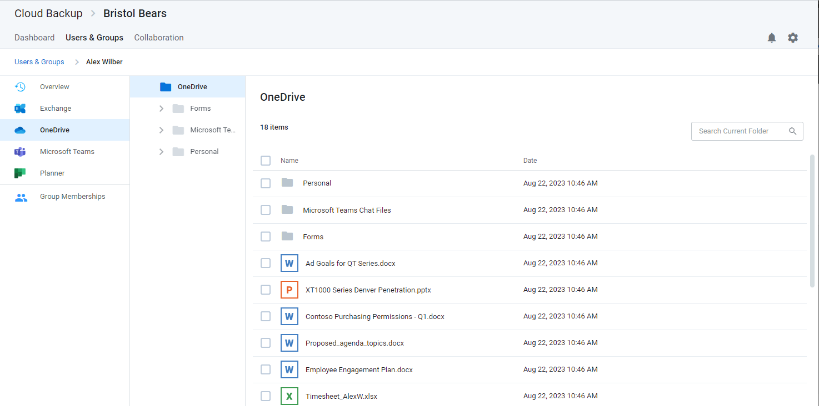

Search for the data you need to restore
Instead of or in combination with navigation, the view also includes a search field which supports a variety of search capabilities.
Enter keywords in the folder or file name you are looking for. To ensure privacy, Cloud Backup does not search the content of files.
Cloud Backup also supports a variety of Advanced Search capabilities, including Elasticsearch, Wildcards, and RegEx.
If multiple items appear in your search, you can sort the items by name and date.

How to restore individual folders and files
You can restore multiple items, including different item types (e.g. files and folders).
When needing to restore more than 200 individual items, it is best practice to perform a bulk restore (e.g. full mailbox, folder, list, etc.) or perform multiple batches of under 200 individual restores. Currently, extremely large batches of individual restores (e.g. over 200) may not complete.
If you restore a file into a folder where an existing file has the same name, the file name will be appended (e.g. filename (1)). This includes restoring items that were deleted, but still exist in the recycle bin.
Every OneDrive for Business restoration is a “new item” restore because Cloud Backup does not overwrite existing items. This means that if the item being restored already exists, Cloud Backup will add the restored item back to the site collection with its name appended with a number in parentheses. On the other hand, if the item does no longer exists, Cloud Backup will add the item without appending the name of the file.

Restoring individual files to the latest snapshot or a previous version
To restore an individual file to the latest snapshot or previous version:
- Select the file
- Click the Restore button that will appear at the top of the list
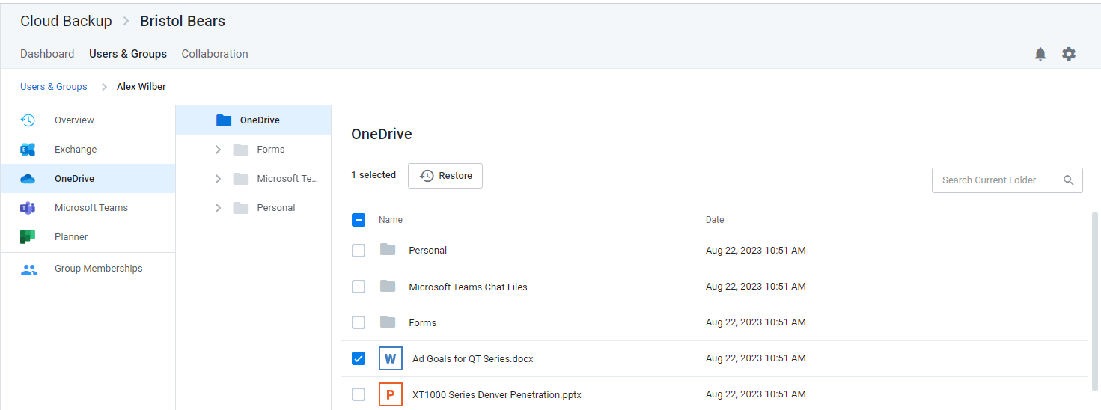
- Select the version to restore and click Validate
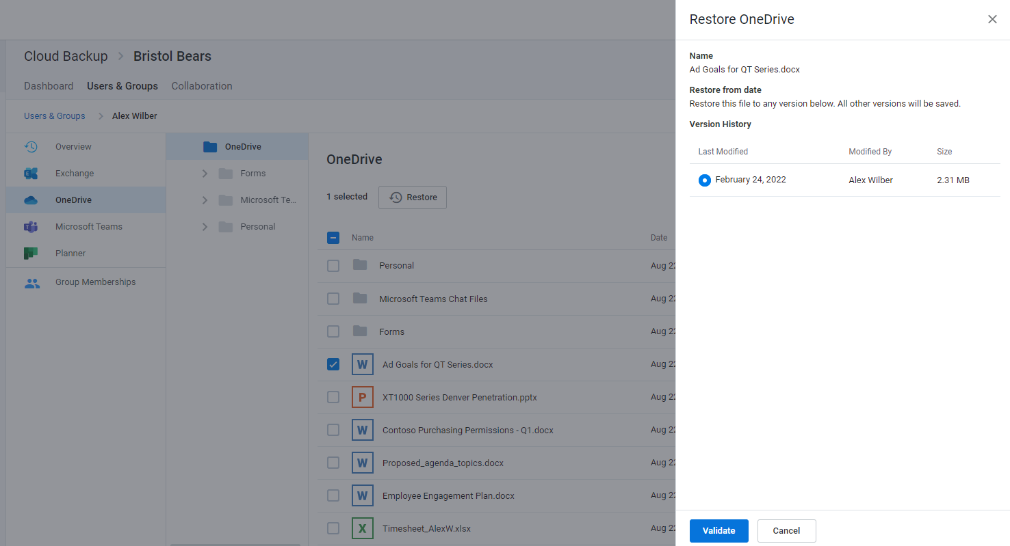
- Upon successful restore prechecks, click Restore
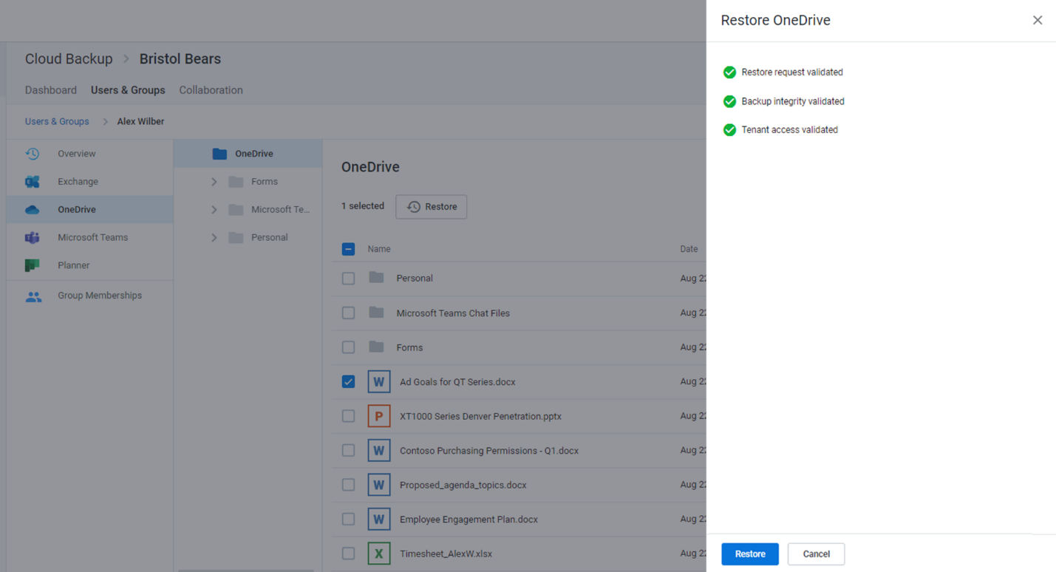

Restoring multiple individual items and/or folders to the latest snapshot or a specific point in time
- Select any number of items
- Click Restore
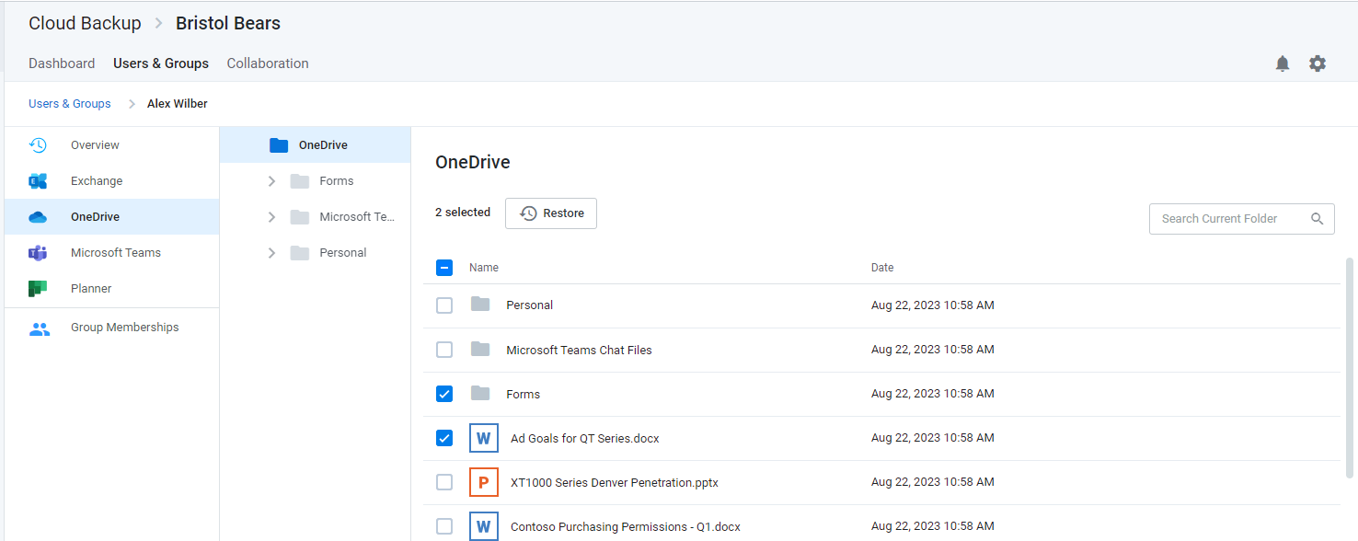
- If you want to restore to the latest snapshot, click Validate and skip to step 7
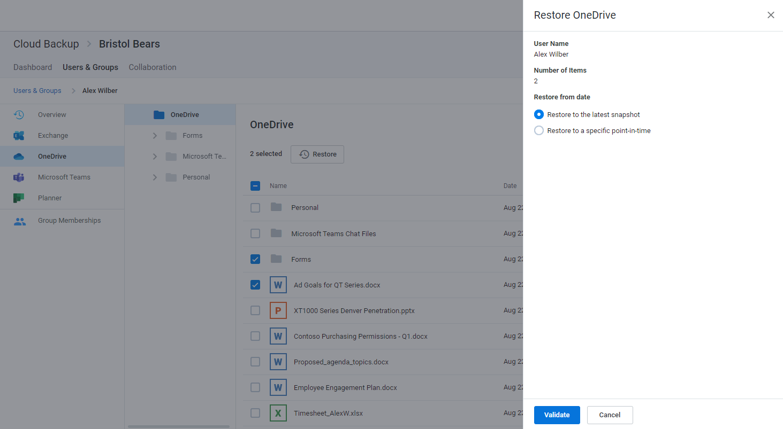
- If you want to restore to a specific point in time, select Restore to a specific point-in-time
- Select a date and time within the available restore range
- Click Validate
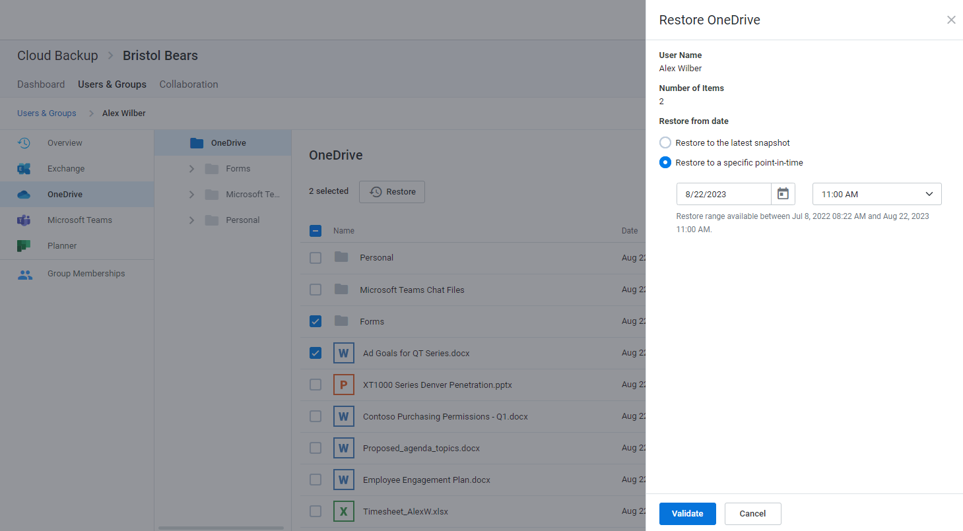
- Upon successful restore prechecks, click Restore
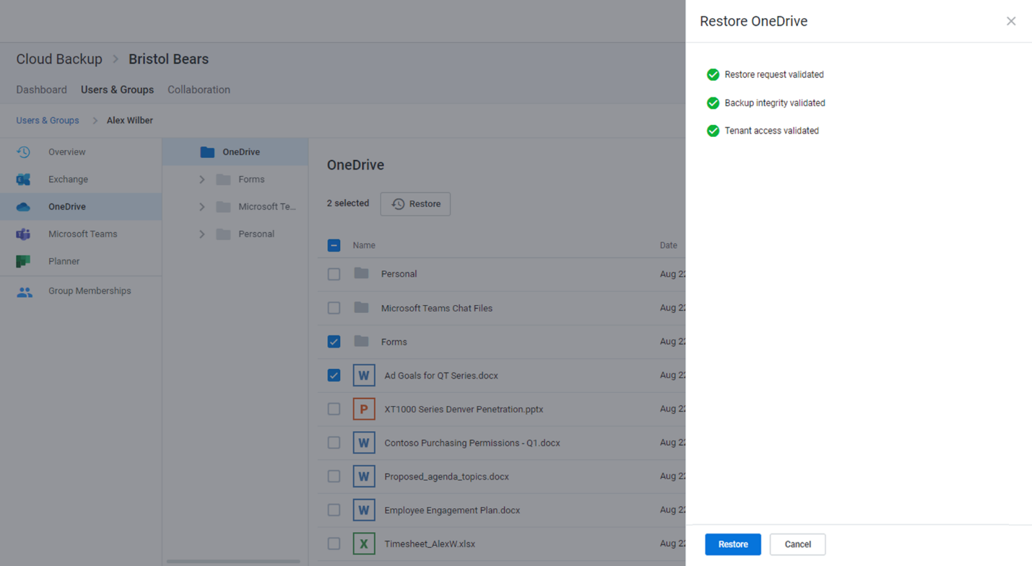

Restoring a full OneDrive for Business account to the latest snapshot or a specific point in time
Cloud Backup also supports the restoration of an entire OneDrive for Business account to the latest snapshot or to a specific point in time.
When a full restore is done with Cloud Backup, it is merged with existing content. In other words, the data is de-duplicated before it is inserted into the account. Cloud Backup does not overwrite or delete data at any time. Therefore, if a file needs to be restored into a folder in which an existing file has the same name, it must be restored as part of an individual restore.
To restore an entire OneDrive for Business account to the latest snapshot or a specific point in time:
- Select all items
- Click Restore
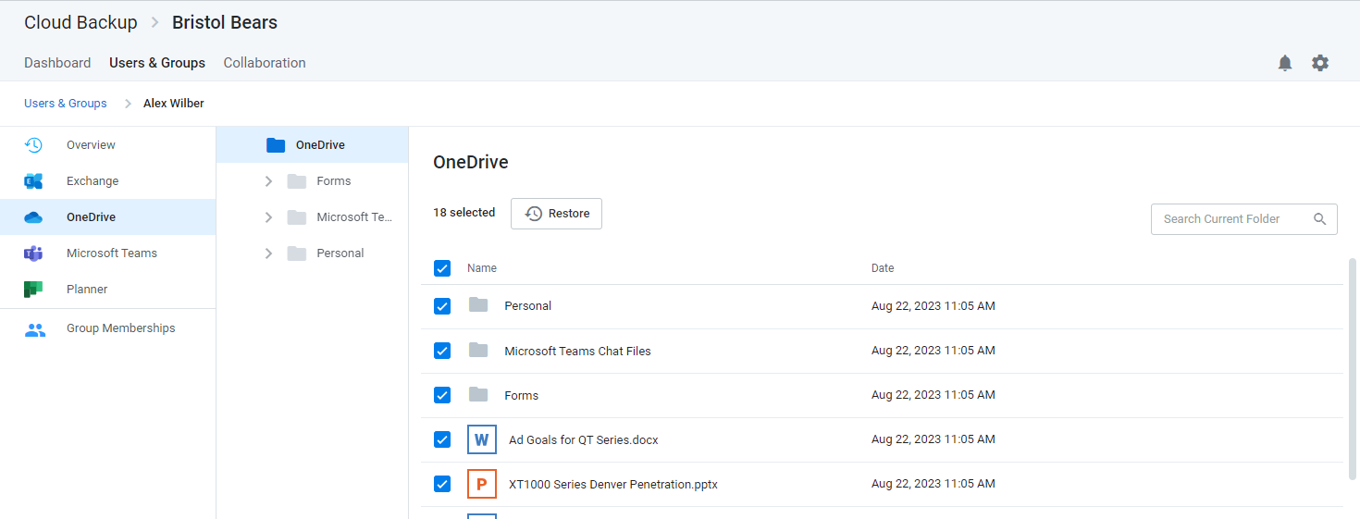
- If you want to restore to the latest snapshot, click Validate and skip to step 7
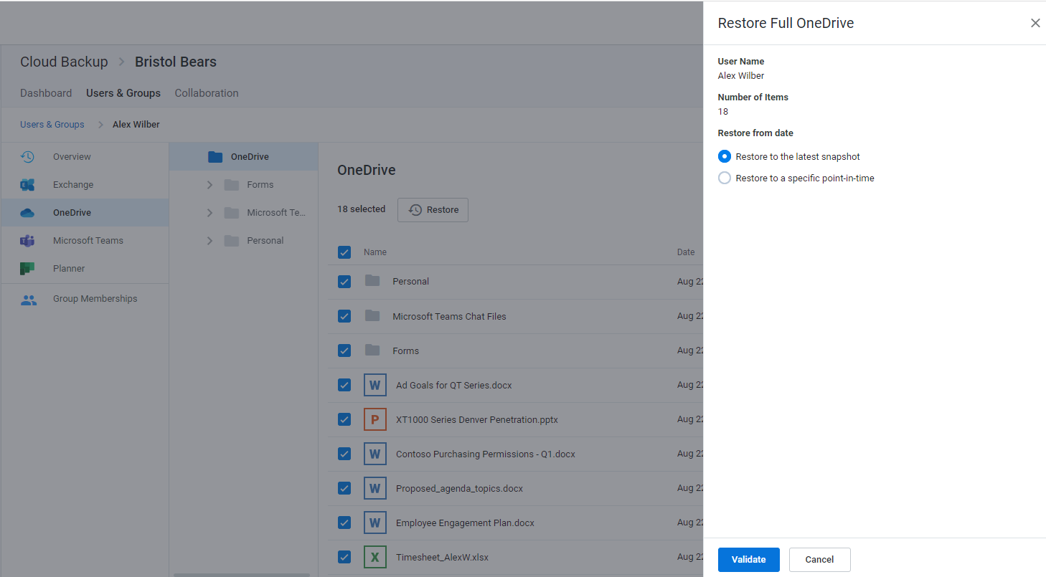
- If you want to restore to a specific point in time, select Restore to a specific point in time
- Use the date and time fields to select the point in time
- Click Validate
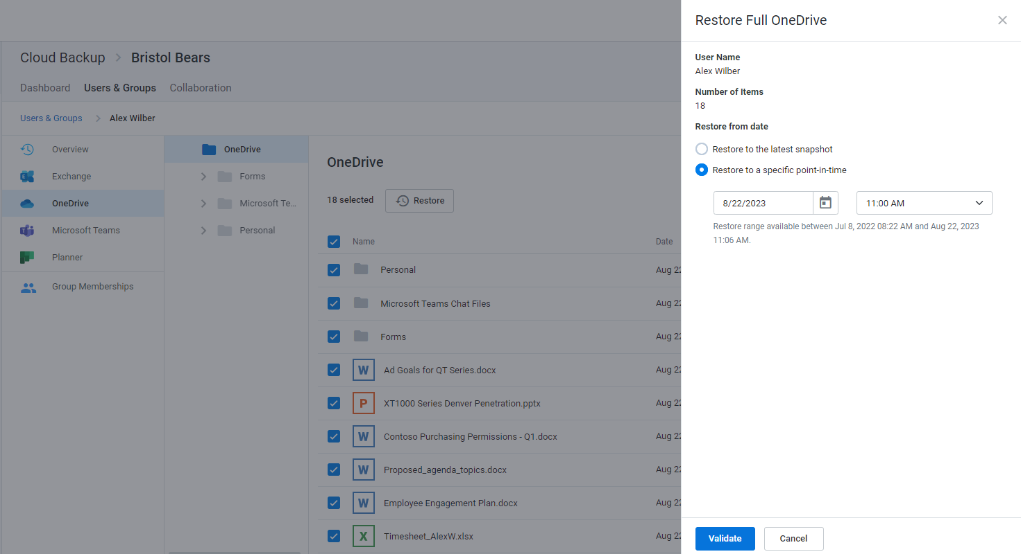
- Upon successful prechecks, click Restore
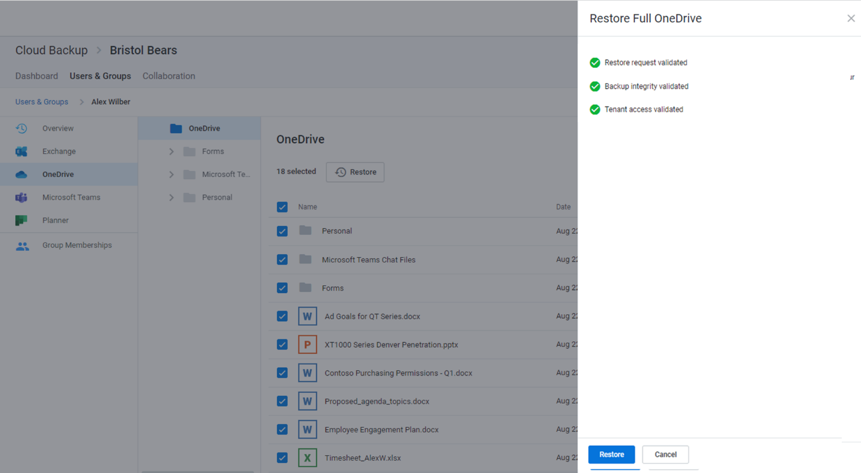

Restore Process
While the restore is initiated with a single click and Cloud Backup makes every effort to restore the content as quickly as possible, the time required to complete the restoration is based on a variety of external factors, including:
- The overall size of the data set being restored.
- Microsoft Office 365 throttling.
- Microsoft Azure throttling.
- The overall availability of Office 365.

OneDrive for Business limitations that may impact Cloud Backup
Cloud Backup backs up data in Office 365. Due to restrictions and limitations when syncing SharePoint libraries to a computer through OneDrive for Business, there may be data that is not synced to Office 365, and therefore not backed up by Cloud Backup.
For more information, see Restrictions and limitations when you sync SharePoint libraries to your computer through OneDrive for Business.

Restoring Microsoft Teams chats
Return to top of document

How to access Microsoft Teams chats
- Open the subscription
- Select the Users & Groups tab
- On the Users tab, click on the user whose data needs to be restored
- Select Microsoft Teams in the left navigation or click the Microsoft Teams Chats tile.

How to restore Teams chats
Here, you can select any chat and click Restore to upload a PDF of the chat into the OneDrive for Business account of the user requesting the restore.
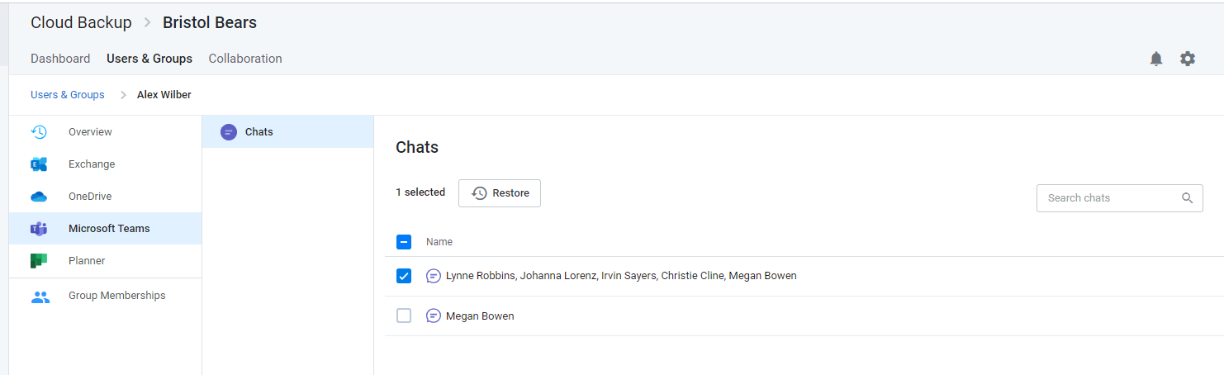
Click Validate to proceed.
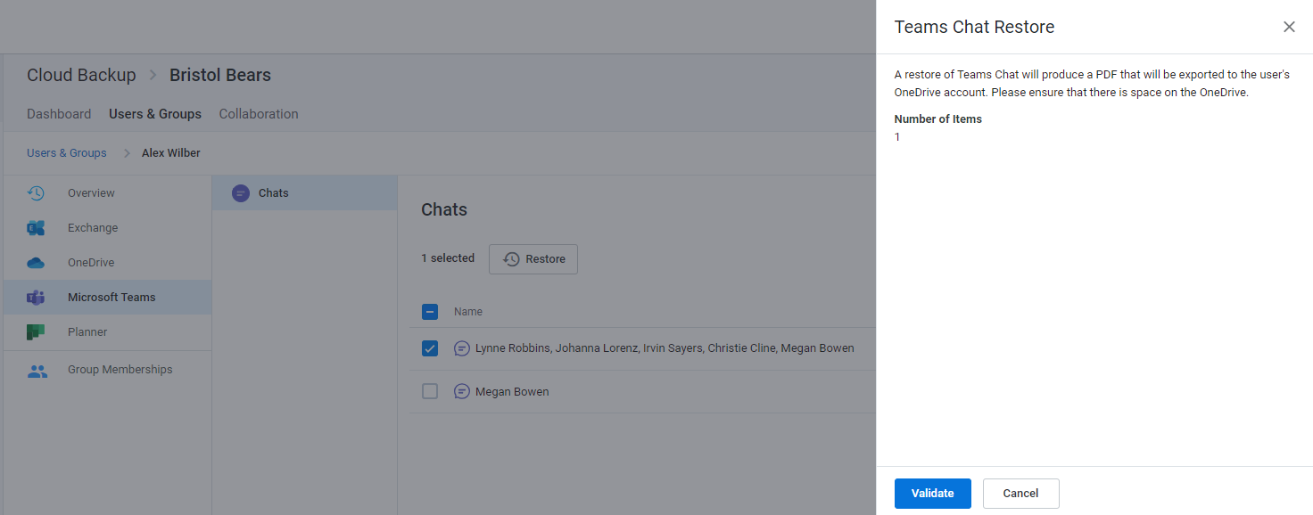
Click Restore
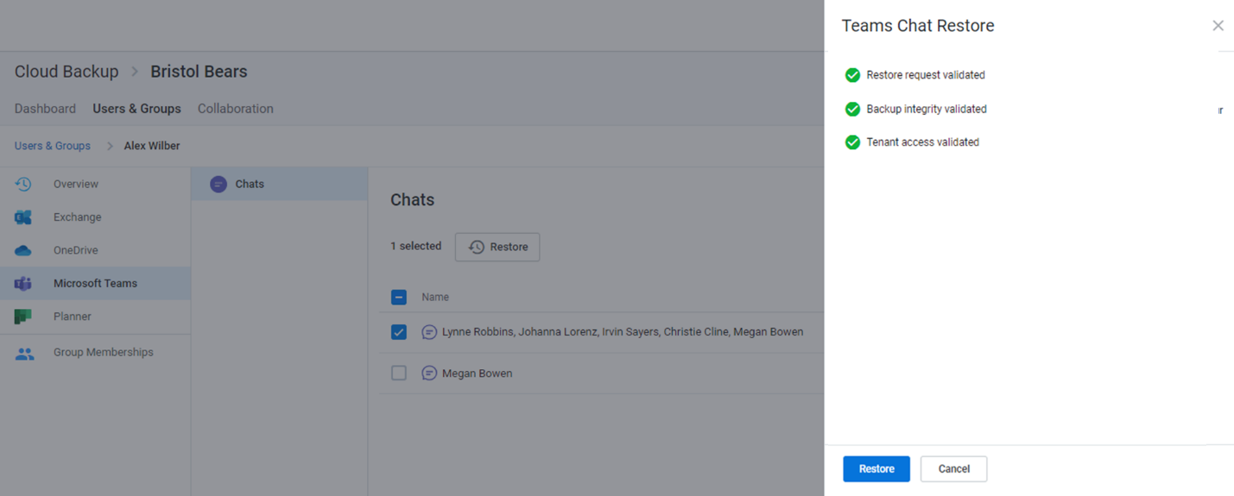

Where to find the restored Teams chat
The PDF file of the restored chat will be in the OneDrive for Business account of the user for whom the restore was performed. E.g., because the restore above was performed on behalf of Adele Vance, the PDF was exported to her OneDrive for Business account with a file name including a timestamp (as shown below). If Alex Wilber requested a restore of the same chat, a PDF would be exported to his OneDrive for Business account.
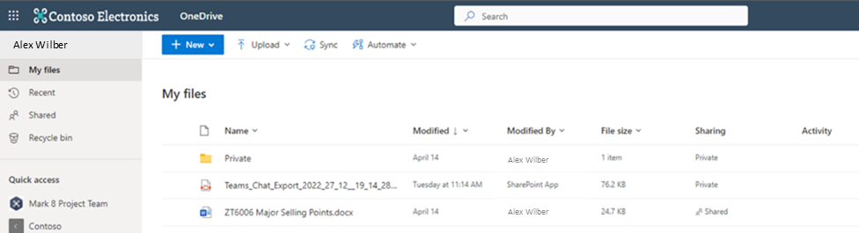
This PDF will include:
- The date and time of the export
- The participants
- The entire history of the chat between the specific participants with timestamps and rich text support
- Other supported chat content, including tables, links, emojis, GIFs, stickers, important tags, and more
Note: If there is a video in the chat, the PDF will include the URL for the video.
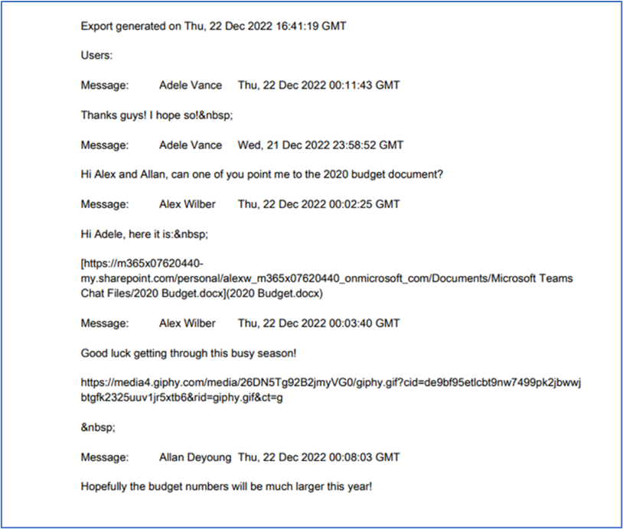

How to restore files shared within a Teams chat
If a chat is deleted, it is likely that the files shared within the chat still exist as they are stored in the user’s OneDrive for Business account.
If they no longer exist in the OneDrive for Business account, you can restore them there. For more information, see Restoring OneDrive for Business account data.

Restoring Microsoft Planner user tasks
Return to top of document
Microsoft Planner includes both user data which includes individual user tasks and group data which includes group plans, buckets, and tasks. If you need to restore one or more user tasks, follow the steps below.
If you need to restore group plans, buckets, or tasks, see Restoring Microsoft Planner collaboration data.

How to access Microsoft Planner user tasks
- Open the subscription
- Select the Users & Groups tab
- On the Users tab, click on the user whose data needs to be restored
- Select Planner in the left navigation or click the Microsoft Planner tile.
This view includes:
- A Viewport on the right through which you can navigate through the Plans to find the task you need to restore.
- A search field to search for the task within Planner, and
- A navigational tree on the left that can be used to find the specific location directly. This navigation will expand to match actions in the Viewport

Navigate to the data you need to restore
- Open the plan to which the user task needs to be restored
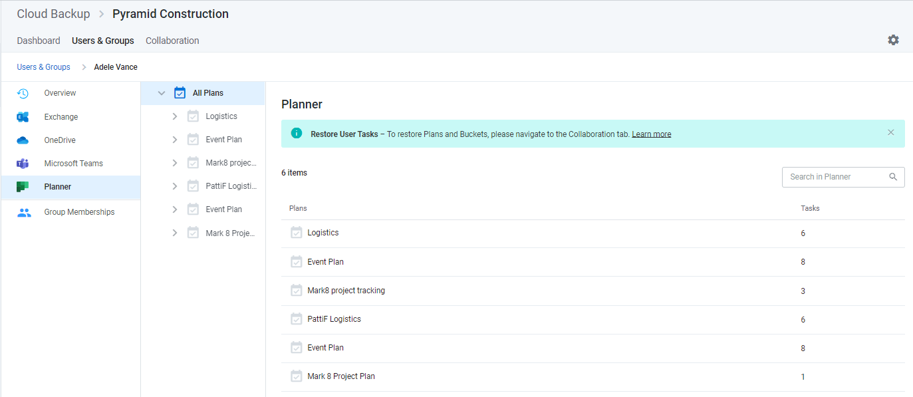
- Open the bucket to which the user task needs to be restored
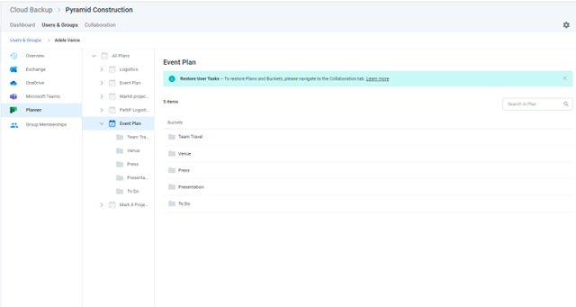
- Select any number of tasks and click the Restore button at the top of the list
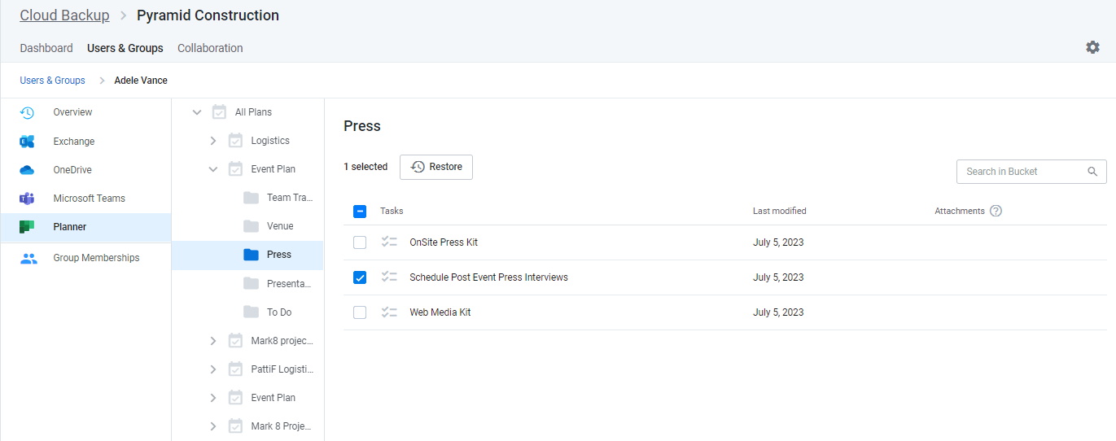
- This will initiate a process to validate the restore request. Click the Restore button to proceed
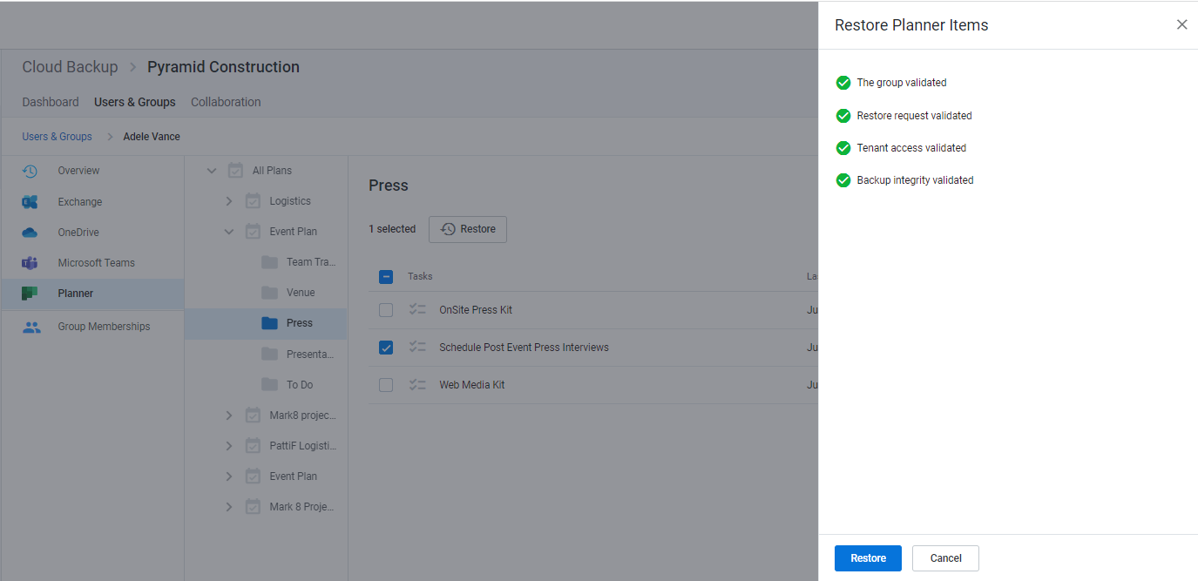

Restoring Microsoft 365 collaboration data
Return to top of document
Collaboration data in Microsoft 365 is also found in multiple applications. For instructions on restoring specific collaboration data, see:
- Restoring Exchange Public Folder data
- Restoring SharePoint data
- Restoring Microsoft 365 groups and Microsoft Teams collaboration data
- Restoring Microsoft Planner collaboration data
Note: While Shared Mailboxes are collaboration data, due to Microsoft APIs, Cloud Backup lists them within user data. For restoring Shared Mailboxes, see Restoring Exchange mailbox data.

Restoring Exchange Public Folder data
Return to top of document

How to access Public Folder data
- Open the subscription
- Select the Collaboration tab in the top navigation
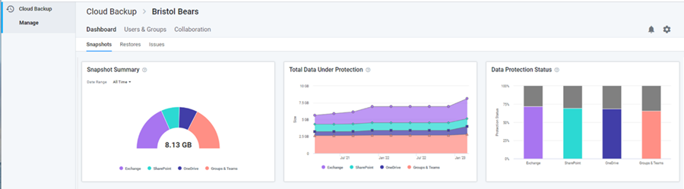
- Select Public Folder in the left navigation or click the Public Folder icon
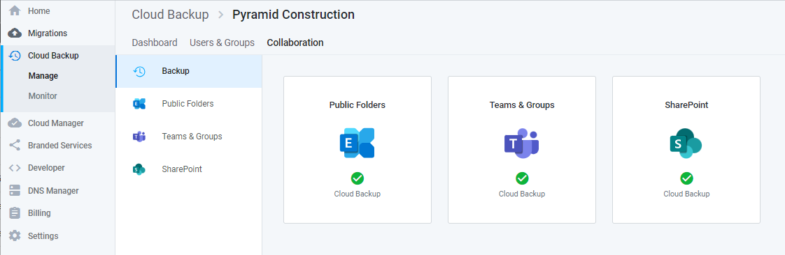
This will open a list of Public Folders. To restore a Public Folder or folders or files within a Public Folder, click on the Public Folder.
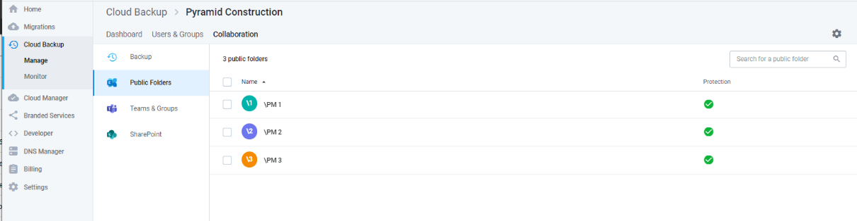

Full Public Folder restore to the latest snapshot or a specific point in time
To restore an entire Public Folder to the latest snapshot or a specific point in time:
- Select all items and click Restore
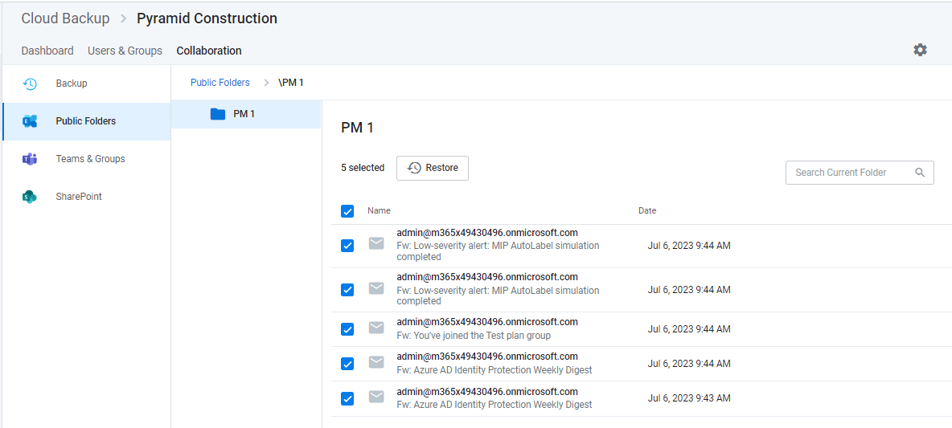
- To restore to the latest snapshot, select Restore to the latest snapshot and click Validate
- To restore to a specific point in time, select Restore to a specific point-in-time, select a date and time and click Validate
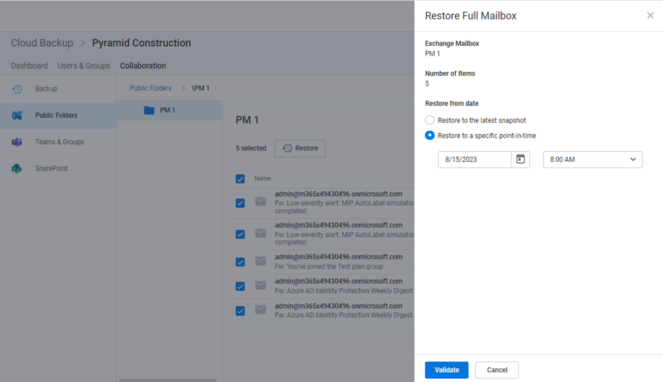
- Upon successful restore prechecks, click Restore
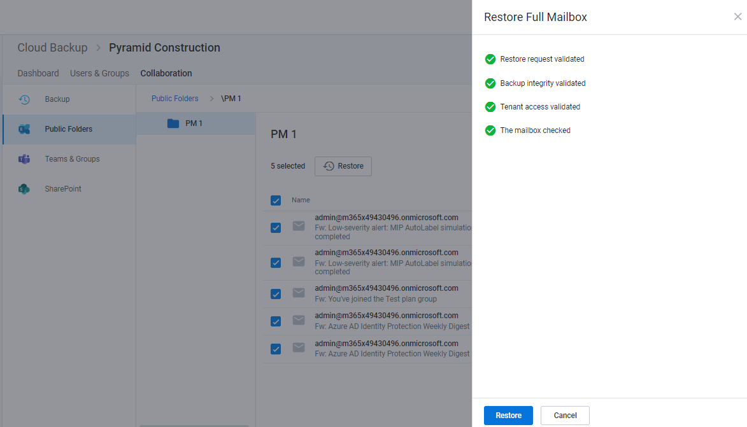

Individual item restore
To restore individual items within a Public Folder:
- Click on the Public Folder
- Select any number of items
- Click the Restore button
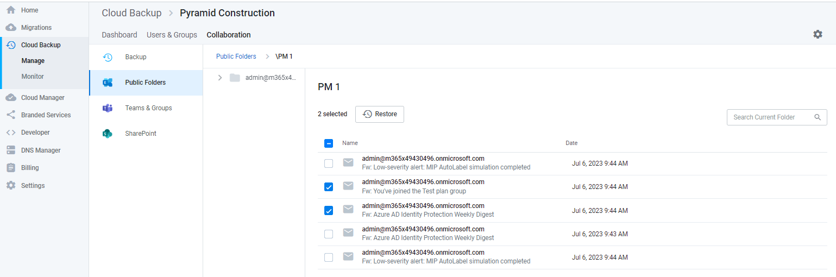

- To restore to the latest snapshot, select Restore to the latest snapshot and click Validate
- To restore to a specific point in time, select Restore to a specific point-in-time, select a date and time and click Validate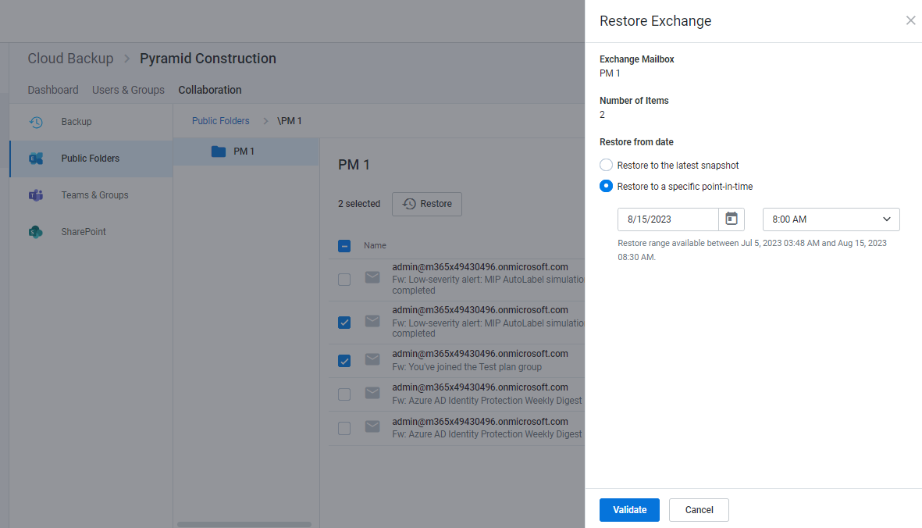
- Upon successful restore prechecks, click Restore
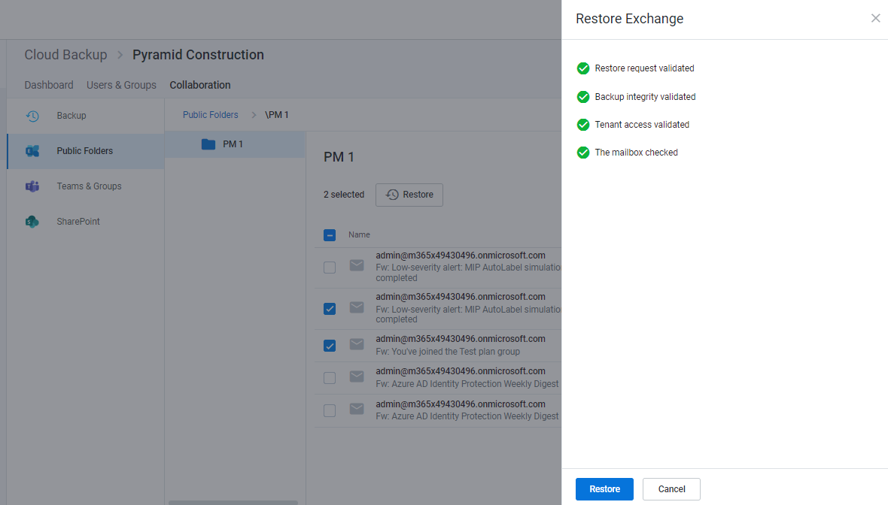

Restoring SharePoint data
Return to top of document

How to access SharePoint data
- Open the subscription
- Select the Collaboration tab in the top navigation
- Select SharePoint in the left navigation or click the SharePoint tile
This will open a list of sites. To restore the site, or the folders and files within a site, click the site. You can also use the search field to find the site that contains the data that needs to be restored.
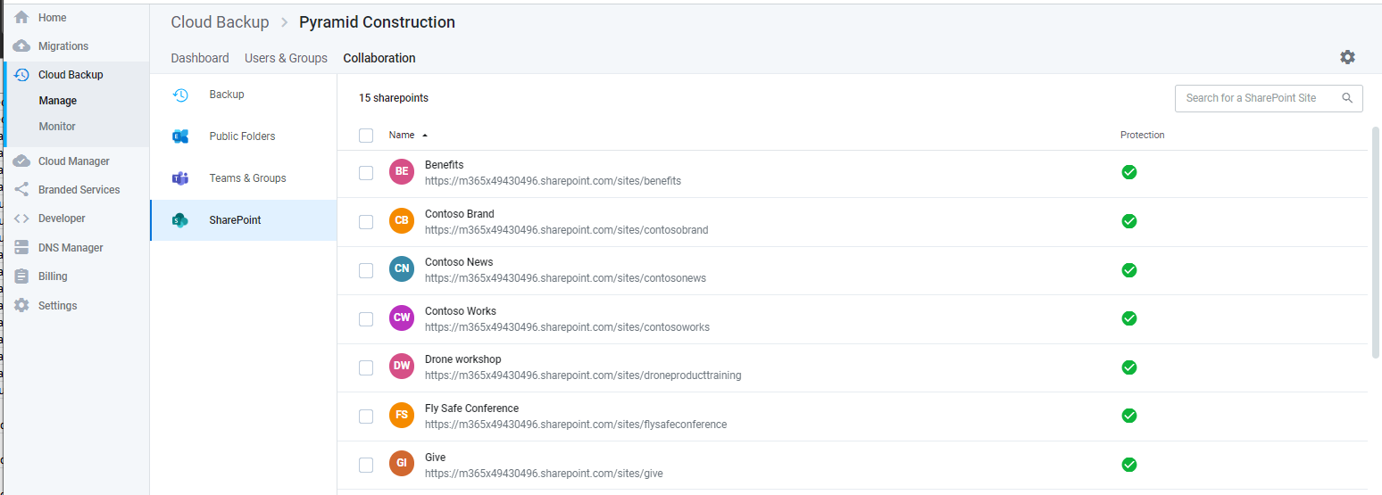
From here, you can navigate to the data or select a SharePoint site and use the search field to find the data you need to restore.
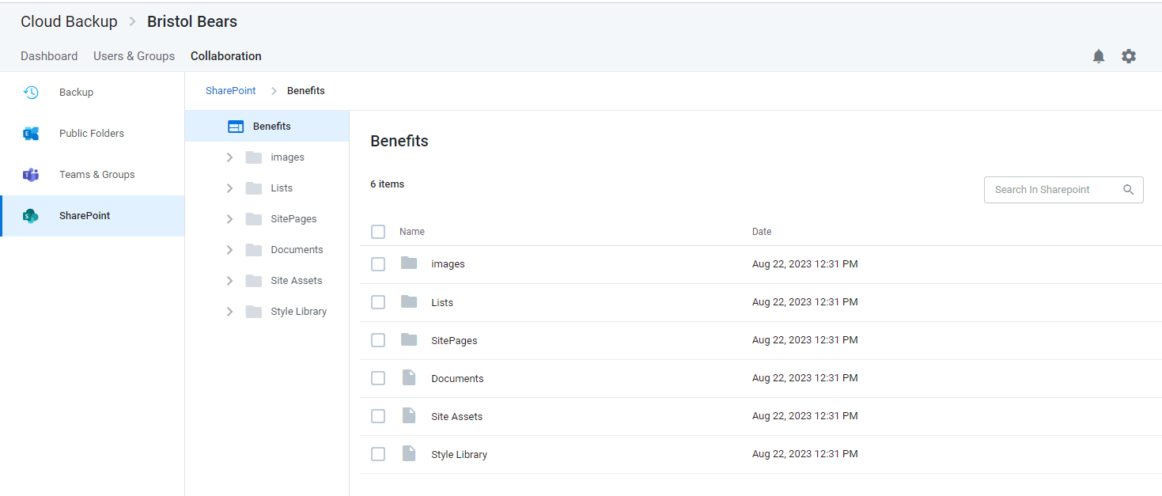

Search for data
Once inside a SharePoint site, you can use the search field and a variety of advanced search capabilities to find the data you need to restore.

Smart Search
Cloud Backup supports a variety of Smart Search queries. To narrow your search to subsites or a specific list type, you can enter the following Smart Search terms.
- subsite:[subsite name] (e.g. subsite:marketing)
- folder:[folder name]
- file:[file name]
- announcement:[announcement name]
- contact:[contact last name]

Advanced Search
Cloud Backup also supports a variety of Advanced Search capabilities, including Elasticsearch, Wildcards, and RegEx.
Note: Currently, the Cloud Backup UI has a search result limit of 500 items. Workarounds for this include the use of browsing to narrow the search within a specific folder.

How to restore a full SharePoint site
You can restore a full SharePoint site to the latest snapshot or to a specific point in time.
When a bulk restore is done with Cloud Backup, it is merged with existing content. In other words, the data is de-duplicated before it is inserted into the account. Cloud Backup does not overwrite or delete data at any time. Therefore, if a file needs to be restored into a folder in which an existing file has the same name, it must be restored as part of an individual restore.
Restoring a subsite will restore all the missing items below the subsite.

Restoring a full SharePoint site to the latest snapshot or a specific point in time
To restore the entire site to the latest snapshot:
- Select all items
- Click the Restore button that will appear at the top of the list
- To restore to the latest snapshot, click Validate and skip to step 7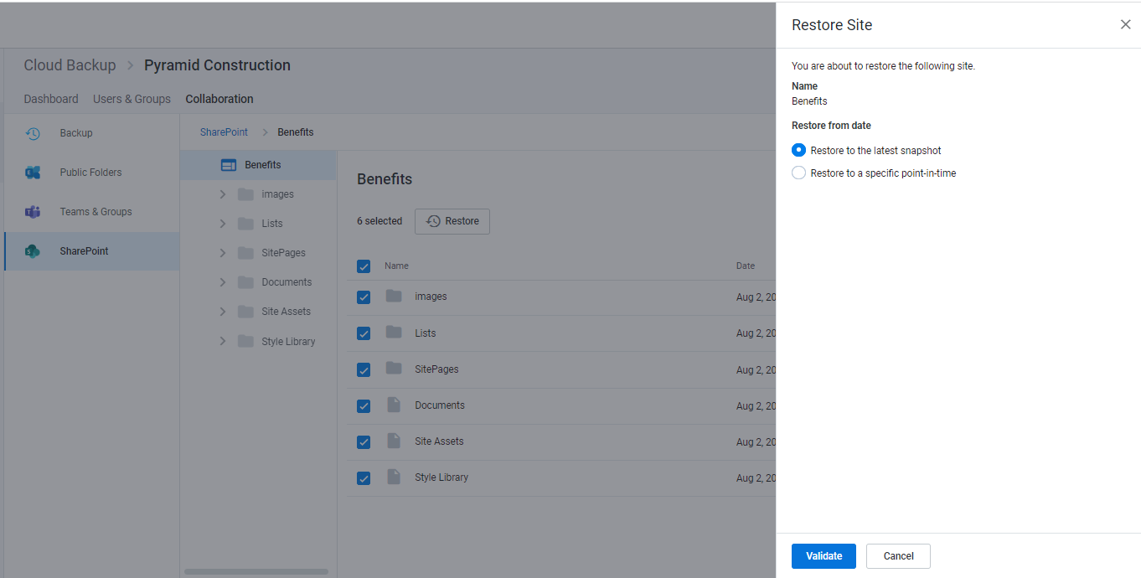
- To restore to a specific point in time, select Restore to a specific point-in-time
- Select the date and time
- Click Validate
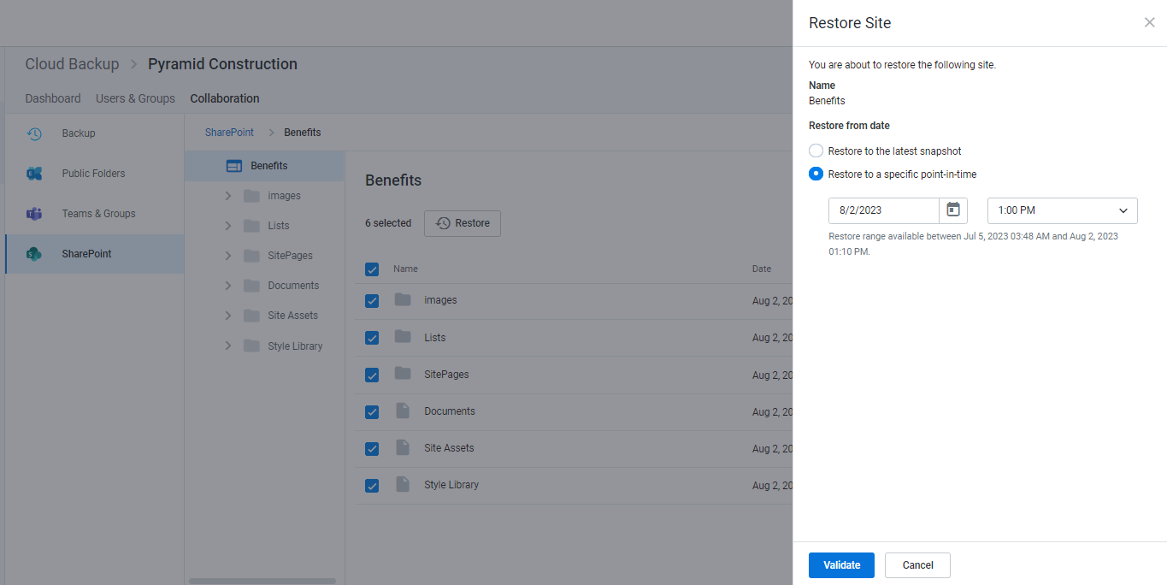
- Upon successful restore prechecks, click Restore
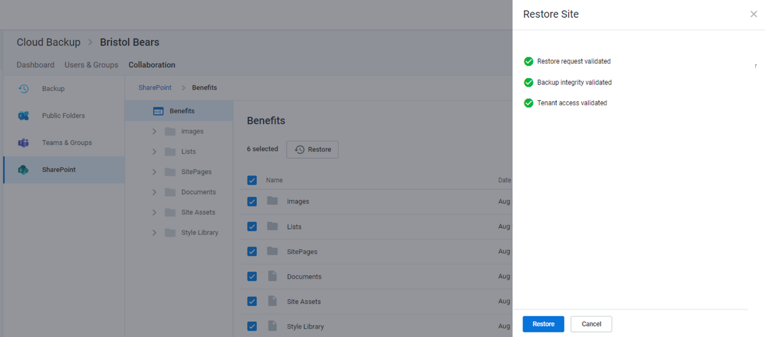

How to restore individual items or folders
You can restore multiple items, including different item types (e.g. subsites, lists, folders, and files) to the latest snapshot or to a specific point in time.
Every SharePoint restoration is a “new item” restore because Cloud Backup does not overwrite existing items. This means that if the item being restored already exists, Cloud Backup will add the restored item back to the site collection with its name appended with a number in parentheses. This includes restoring items, including versions, that were deleted, but still exist in the recycle bin.
On the other hand, if the item does no longer exists, Cloud Backup will add the item without appending the name of the file.
When needing to restore more than 200 individual items, it is best practice to perform a bulk restore (e.g. full mailbox, folder, list, etc.) or perform multiple batches of under 200 individual restores. Currently, extremely large batches of individual restores (e.g. over 200) may not complete.

Restoring an individual file to the latest snapshot or a previous version
To restore an individual file to the latest snapshot or a previous version:
- Select the file
- Click Restore
- Select the version
- Click Validate
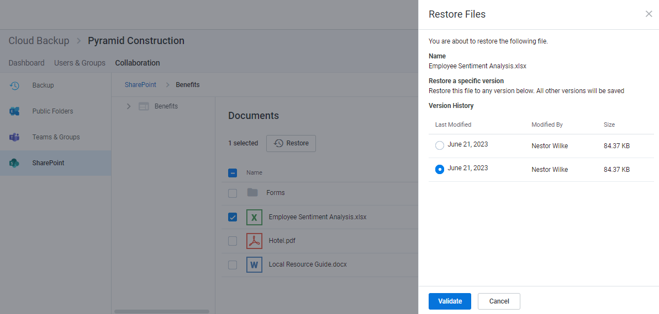

Restoring multiple items or folders to the latest snapshot or a specific point in time
- Select any number of items
- Click the Restore button that will appear at the top of the list
- To restore to the latest snapshot, click Validate and skip to step 7
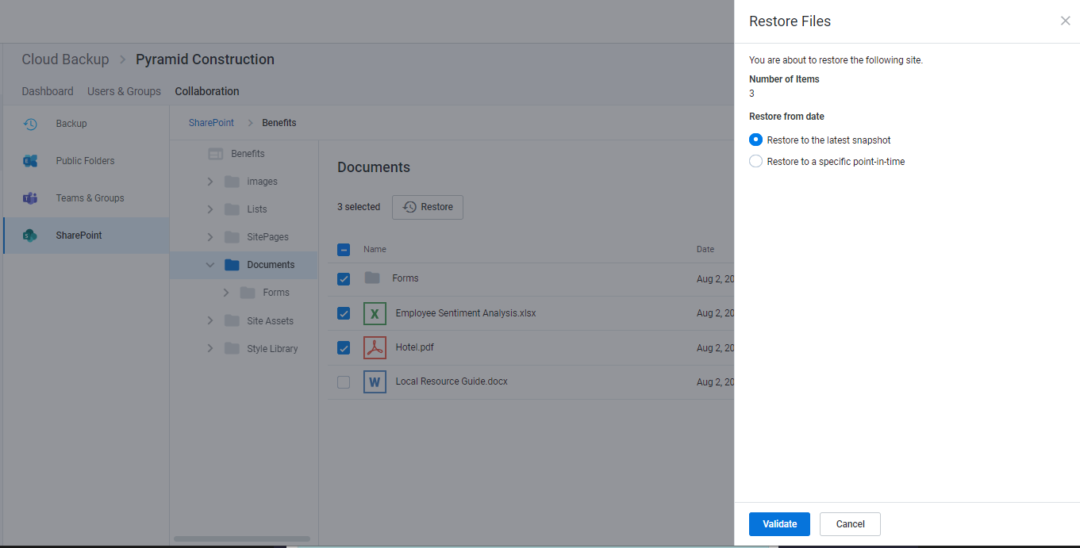

- To restore to a specific point in time, select Restore to a specific point-in-time
- Select a date and time within the available restore range
- Click Validate
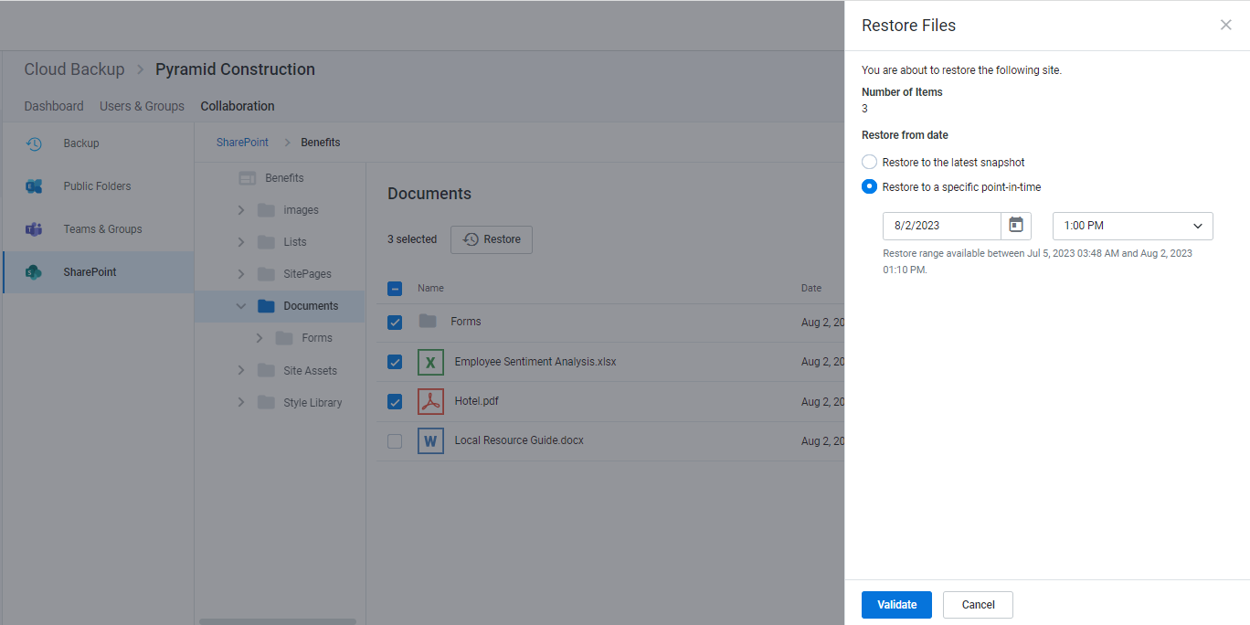
- Upon successful restore prechecks, click Restore
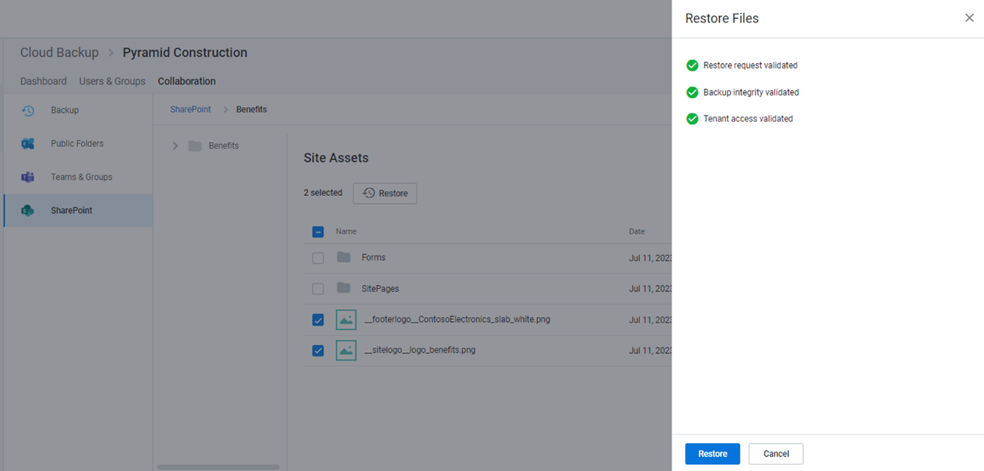

Restore process
Clicking Restore for any restore scenario will initiate a validation process. Upon completion, click Restore to proceed.
While the restore is initiated with a single click and Cloud Backup makes every effort to restore the content as quickly as possible, the time required to complete the restoration is based on a variety of external factors, including:
- The overall size of the data set being restored.
- Microsoft 365 throttling.
- Microsoft Azure throttling.
- The overall availability of Microsoft 365.

Additional details and exceptions

Restoring hyperlinks in a SharePoint list
Currently, the Microsoft Graph API does not support a hyperlink column type. Therefore, when restoring a SharePoint list, instead of restoring hyperlinks, Cloud Backup will restore each component of the hyperlink (description and URL) separately within each cell.

SharePoint Site Collection in Recycle Bin
SharePoint only supports a single instance of a Site Collection URL. If Cloud Backup detects that a Site Collection exists in the SharePoint Recycle Bin, the following Error message will appear.
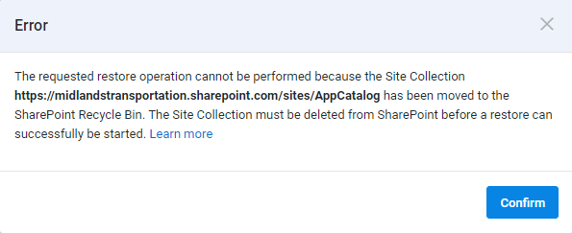
If deleting the Site Collection from the Recycle Bin is not an option, there are two additional ways to resolve this error.
- Restore the Site Collection from the SharePoint Recycle Bin, then perform a merge restore with Cloud Backup
- Wait until the SharePoint Recycle Bin retention period has expired (30 days)
Note: SharePoint Online does not allow some Site Collections, including the root SharePoint Site Collection (e.g. midlandstransportation.sharepoint.com), to be removed from the Recycle Bin. For more information, contact Microsoft Support.

Customizations not supported
Cloud Backup currently does not back up SharePoint customization including, but not limited to third-party web parts, workflows, permissions, and list columns. SkyKick regularly reviews partner feedback to inform product development, and will keep partners informed of new features as they are released.

Restoring Microsoft 365 groups and Microsoft Teams collaboration data
Return to top of document
Note: Because Microsoft Teams chats are user data, to restore chats, see Restoring Microsoft Teams chats.

How to access to Microsoft 365 groups and Microsoft Teams collaboration data
There are two ways to access Microsoft Teams and Microsoft 365 group data in Cloud Backup.
One route is to select the Collaboration tab in the top navigation and Teams & Groups in the left navigation. Here, you can filter by types of Groups and can perform a search for the specific Team or Group.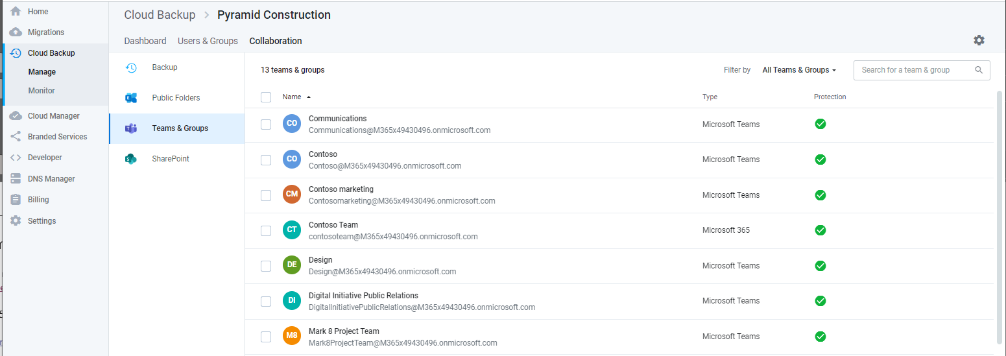
Another route is to select Users & Groups tab in the top navigation and then select the Groups tab.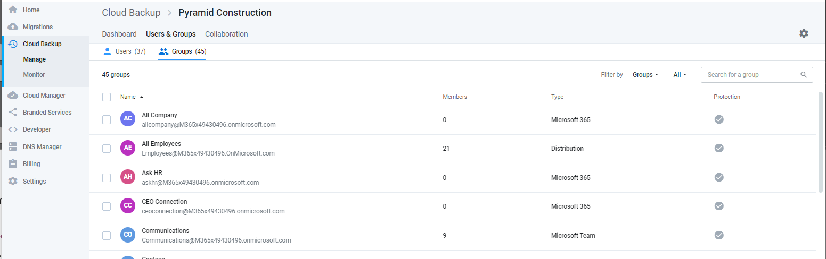
If you select a Microsoft Team, you will see a list of data which includes:
- Channels
- Files
- Communications (Group mailbox)
- Calendar (Group calendar)
- Notebook
- Site
- Planner
- Members
Note: Cloud Backup currently supports the protection and restore of Teams standard and private channels. Support for shared channels is coming soon.
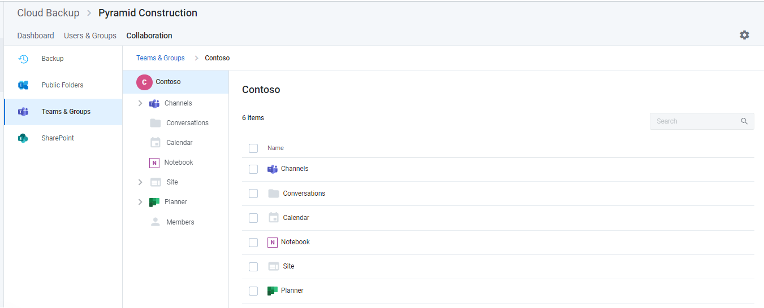
Note: Any Microsoft 365 group that is not a Microsoft Team will include the same list of data with the exception of channels.

Perform a full restore by data type
If you need to perform a full restore of all data by type (e.g. all channels and files), select any number of rows and click the Restore button that will appear above the list.
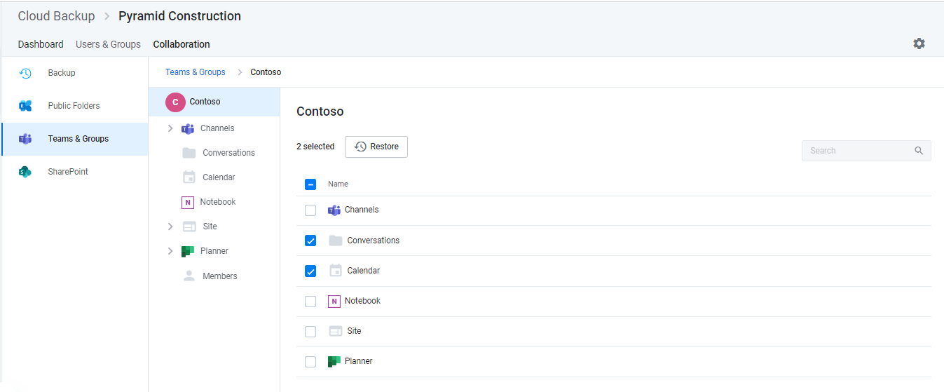
This will initiate a set of validation steps. Upon completion, click Restore to proceed.
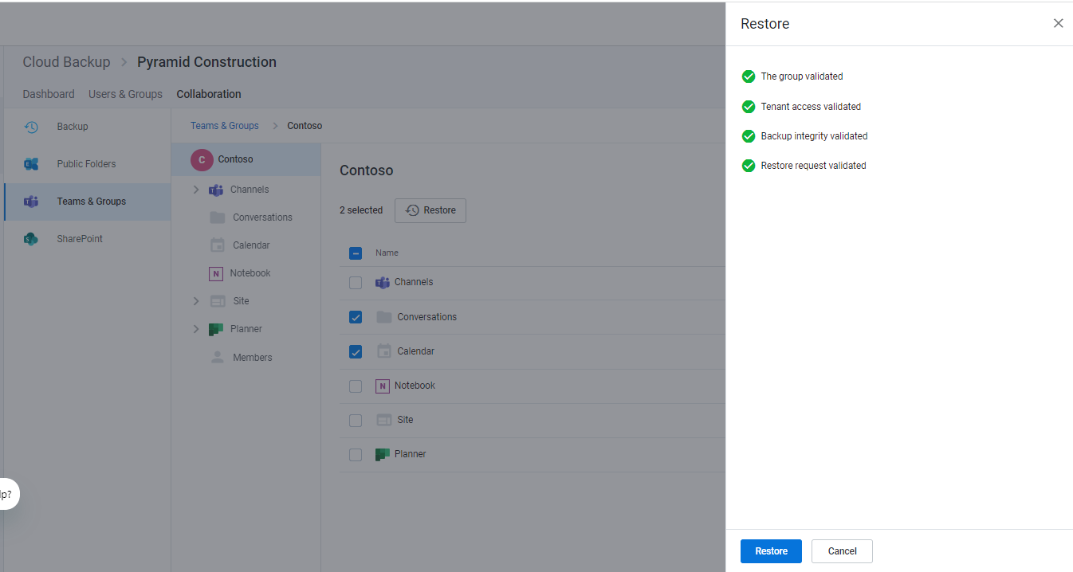

Perform individual item restores
If you want to restore one or more items within one of the data types in the list, use the tree view on the left to navigate into the Channel, folder, Notebook, Site, or Planner.
For example, to restore documents:
- Open the Site
- Open the Documents folder
- Select the files to restore
- Click the Restore button
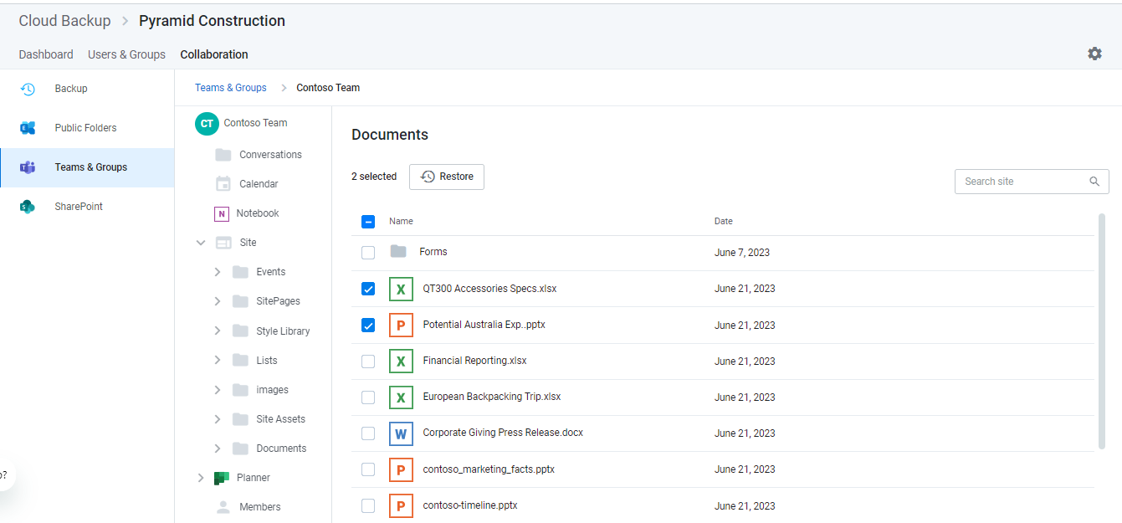
This will initiate a set of validation steps as described above. Upon completion, click Restore to proceed.
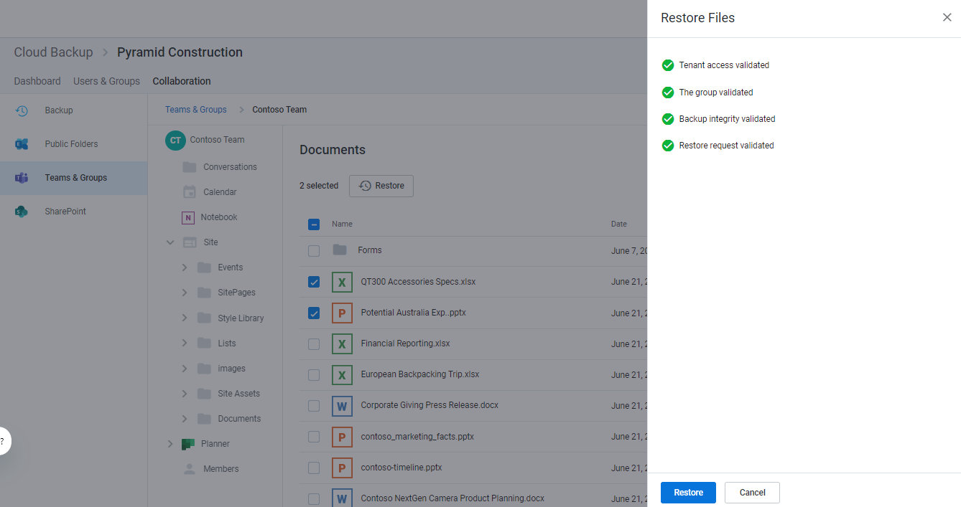

Perform a full restore of a Microsoft Team or Microsoft 365 group
If you want to restore the entire Microsoft 365 Group, select all top-level folders and items and click the Restore button.
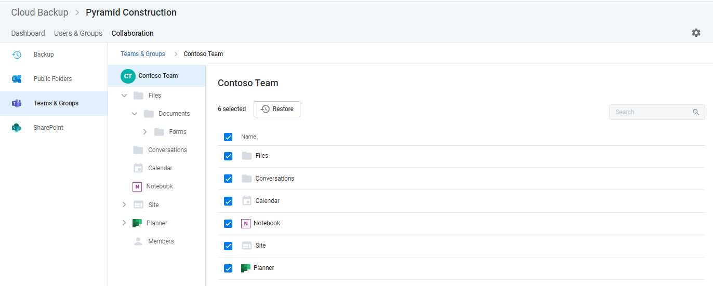
This will initiate a set of validation steps as described above. Upon completion, click Restore to proceed.
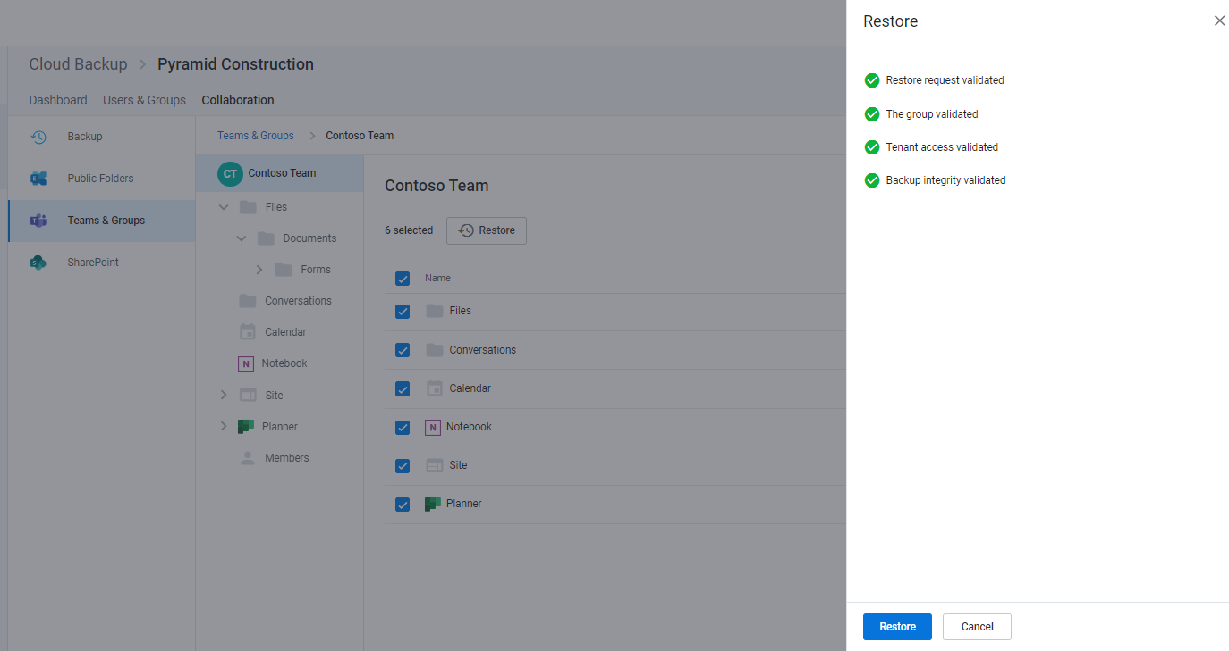

Restoring channel posts
Channel posts are the conversations that occur within a Team.
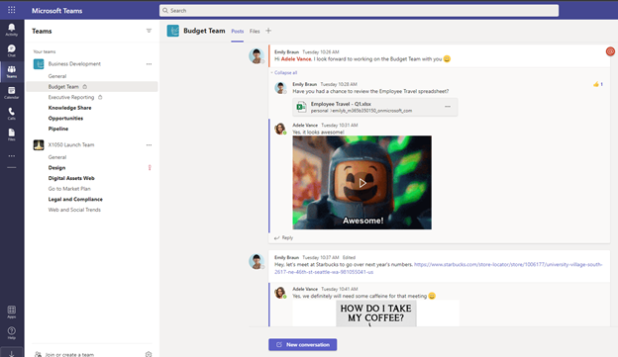
The restore process for channel posts is different than the process of restoring other Microsoft 365 data from Cloud Backup. This is due to current Microsoft API limitations that do not support writing data back into channel posts. To address this limitation, Cloud Backup instead will create and export a PDF file of the backed-up channel posts to the Files tab of that specific channel.
Once you have navigated to the channel, select Posts and click Restore.
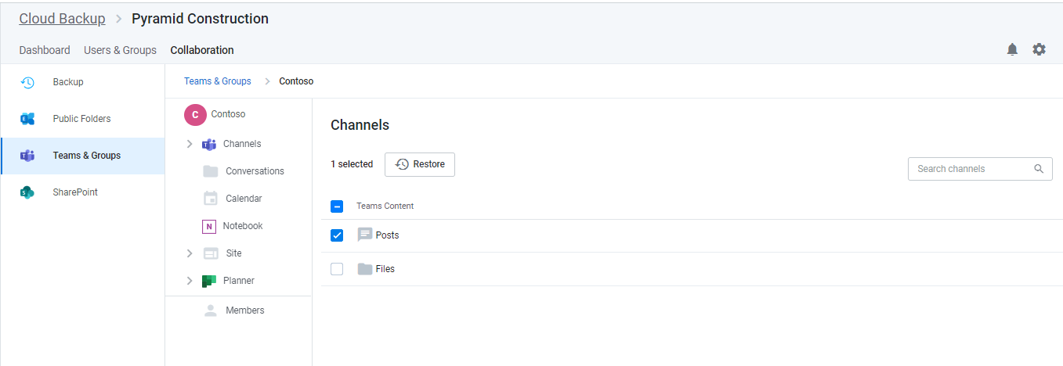
Upon successful completion of restore prechecks, click Restore.
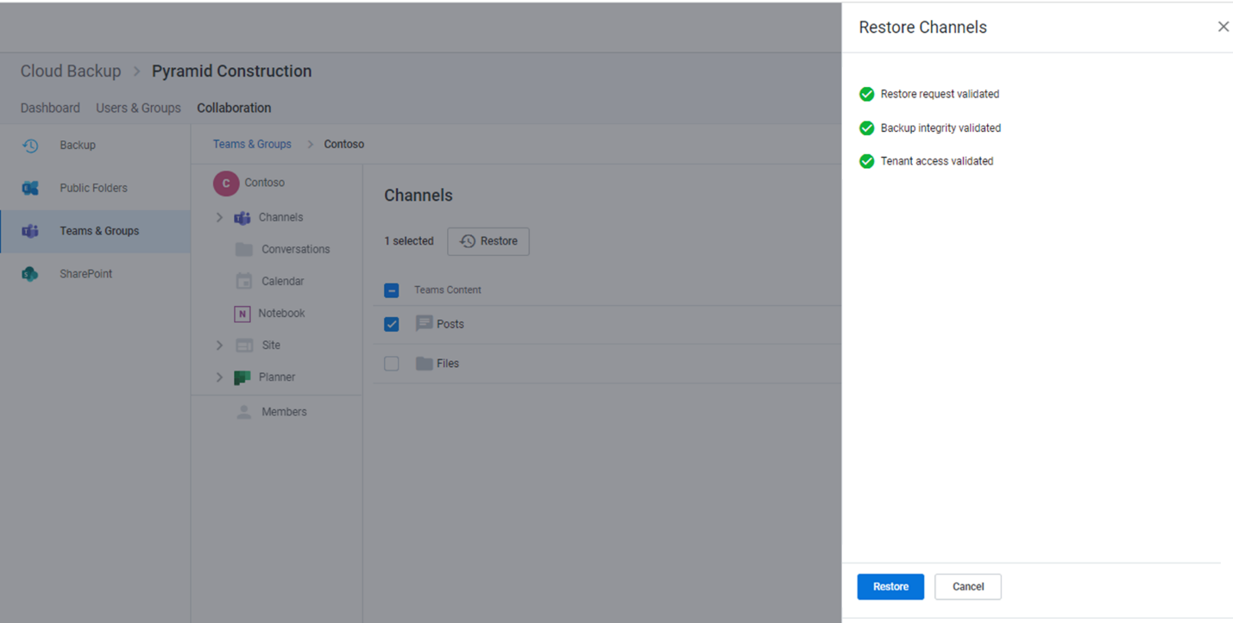
This will initiate the process of creating and exporting a PDF file of the backed-up channel data to the Files tab of the channel.
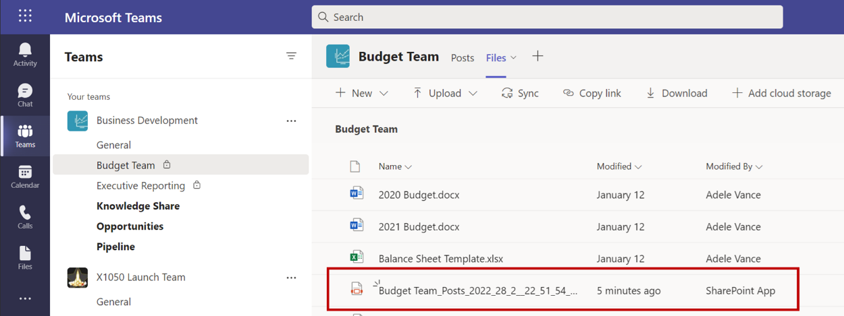
This PDF includes:
- The date and time of the export
- The Team and channel name
- The entire history of posts and replies in the channel with timestamps and rich text support
- Other supported channel post content, including tables, links, emojis, GIFs, stickers, important tags, and more
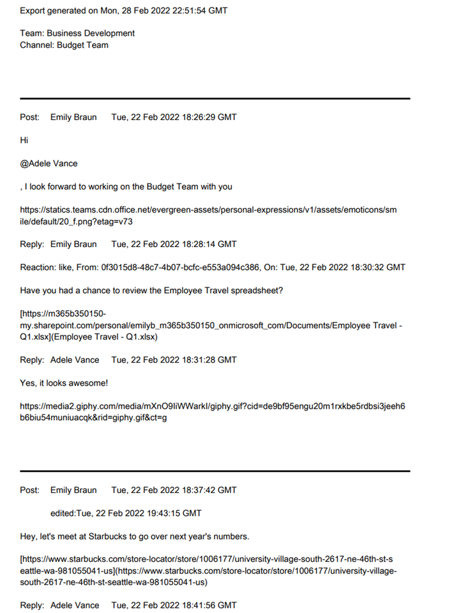
When complete an email notification will be sent and an associated alert will be generated in the Notifications bell.

Additional details for uncommon scenarios

Protection of files in a SharePoint document library but not under channel Files
The files that appear under Files in a channel are contained in a folder of the channel’s SharePoint document library (see below). This folder and all files within it are supported for backup and restore. However, there may be other files in that same document library that are not in that folder and therefore do not appear in the Files of the channel or under the channel files in Cloud Backup.
Such files contained in the SharePoint site of a standard channel are backed up and can be restored as part of a full restore of the SharePoint site. However, currently, the restore of private channel files is limited to the files listed in the Files in the private channel.
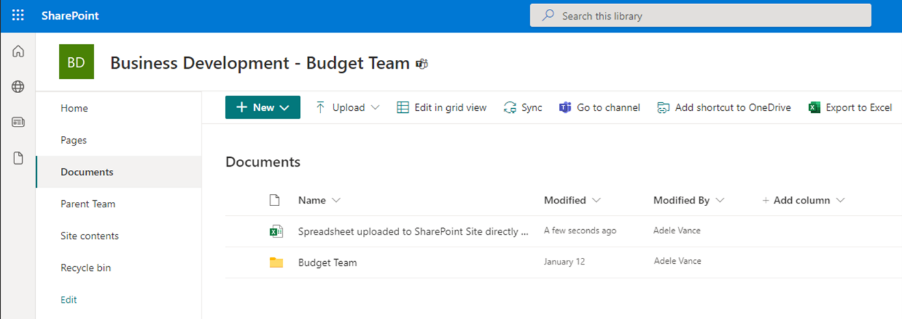

Restoring a channel within 30 days of deletion
When a Teams channel (standard or private) is deleted, it is retained in a recycle bin for 30 days. During this time a new channel cannot be created with the same name as the deleted channel. Therefore, if you need to restore a channel that was deleted within the last 30 days, you must first restore the channel from within Teams.

Restoring private channels
To restore a private channel, at least one user who was an owner of the channel when last backed up must be active on the tenant. In the event this is not the case, the private channel cannot be restored.
Known Issue: Cloud Backup will still attempt to restore the private channel and may falsely report a successful restore but nothing will be restored.

Known issue restoring certain Teams channels
There is currently a restore scenario that Cloud Backup does not support. When a channel has been deleted for more than 30 days and then a new one is created with the same name, Microsoft will create a new URL for it. While the new channel may have the same “friendly name” as the original channel, on the backend, Microsoft amends the URL and permanently removes the availability of the URL of the original channel.
Cloud Backup will back up all such channels. However, because Cloud Backup restores data to the last location from which it was backed up, this permanent removal of the URL associated with the original channel blocks Cloud Backup from restoring the data.
SkyKick is investigating options for resolution.

Unsupported Teams Data
The following Teams data is not supported.

Microsoft Teams (free) and Microsoft Teams Essentials
Cloud Backup uses an Azure AD Application for secure access to Microsoft data. Microsoft currently does not allow the installation of third-party Azure AD Applications for access to Microsoft Teams (free) or Microsoft Teams Essentials. Therefore, until this policy changes, Cloud Backup cannot back up data in these versions of Microsoft Teams.

Microsoft Teams Break Out Rooms
There are currently no APIs available for access to data within Microsoft Teams Break Out Rooms. When APIs become available, we will add backup of this data to our product roadmap.

Restoring Microsoft Planner collaboration data
Return to top of document
Microsoft Planner includes both user data comprised of individual user tasks and group data comprised of group plans, buckets, and tasks. For instructions on restoring user tasks, see Restoring Microsoft Planner user tasks.

How to access Microsoft Planner collaboration data
If you need to restore Microsoft Planner group data:
- Open the subscription
- Select the Collaboration tab in the top navigation
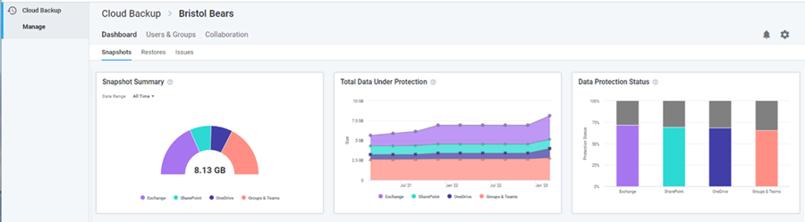
- Select Teams & Groups in the left navigation
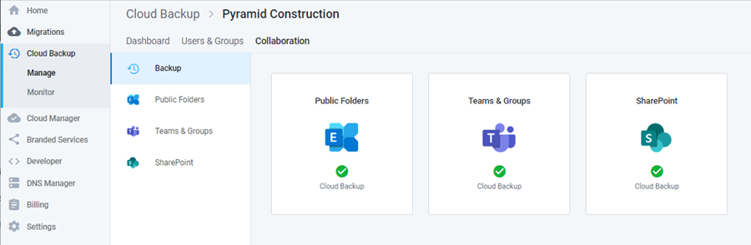
- Click on the Group or Team whose Planner data you want to restore
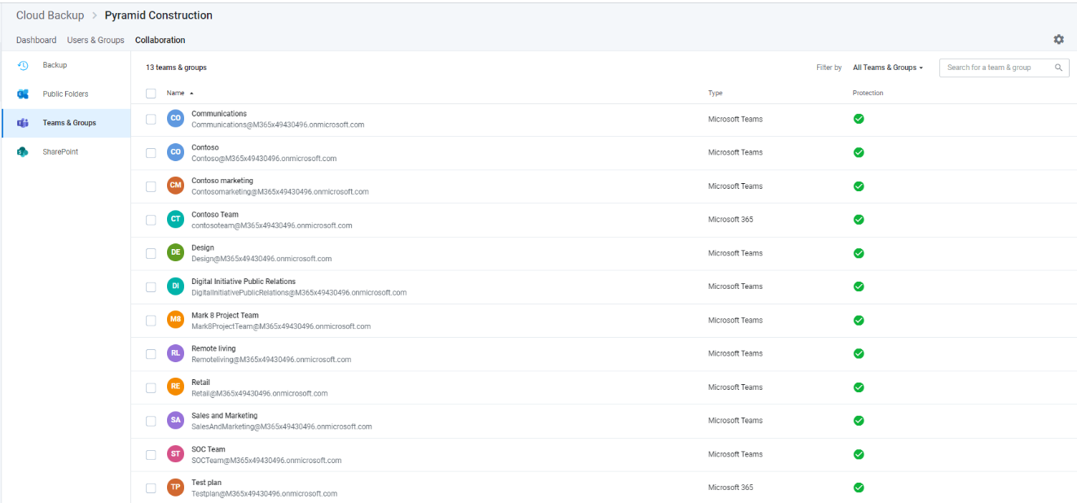
This will open a page where you can search for or navigate to the data you need to restore.
- In the Viewport on the right, you can navigate to and into the plans to find and restore the data you need
- You can use the search box to search across Planner for the data you need to restore, or
- You can use the navigational tree on the left to find the specific data.
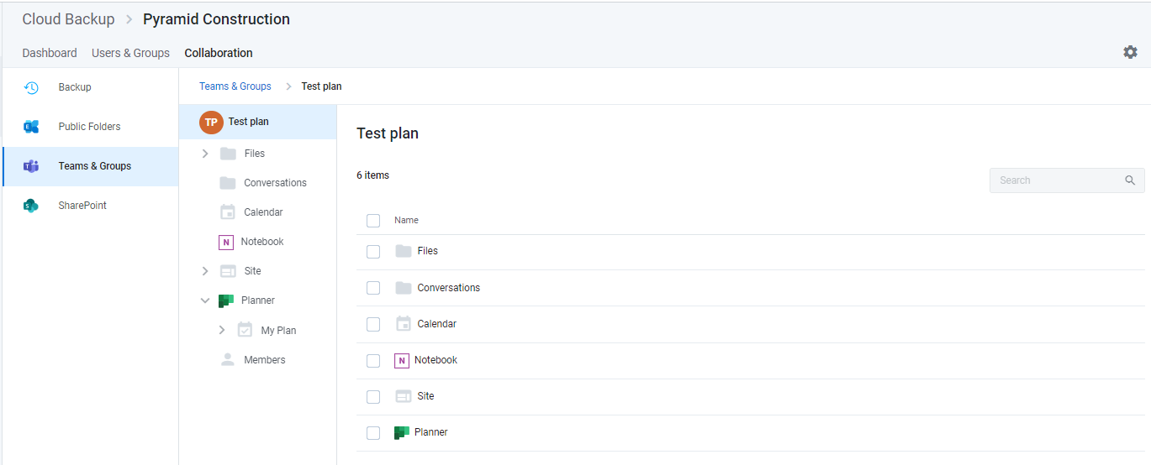

Restore all Planner collaboration data for a group
To restore all Planner collaboration data select Planner in the Viewport and click the Restore button at the top of the list of collaboration data.
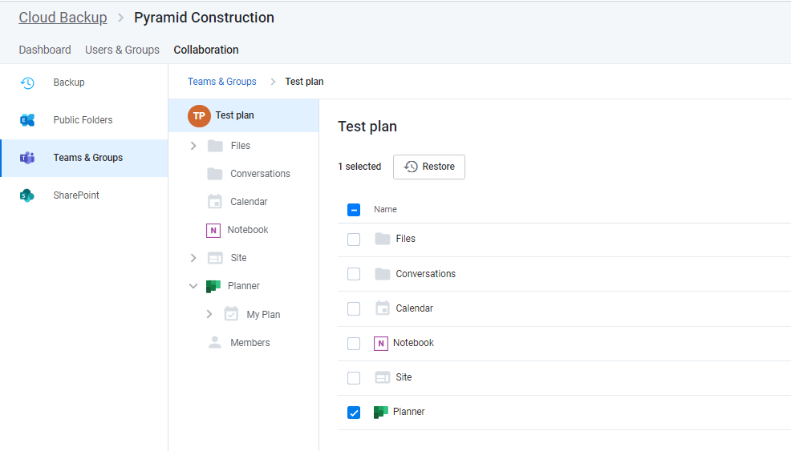
This will initiate a process to validate the restore request. Click the Restore button to proceed.
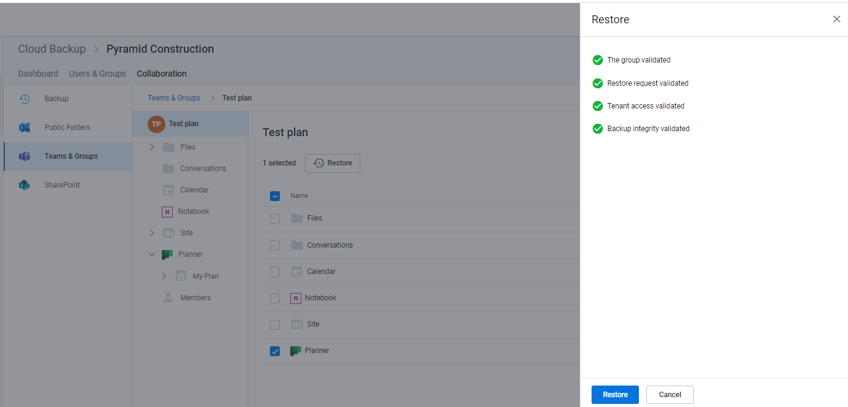

Restore one or more plans
To restore one or more plans,
- Click Planner in the Viewport or open Planner in the navigational tree
- Select one or more plans you want to restore
- Click the Restore button
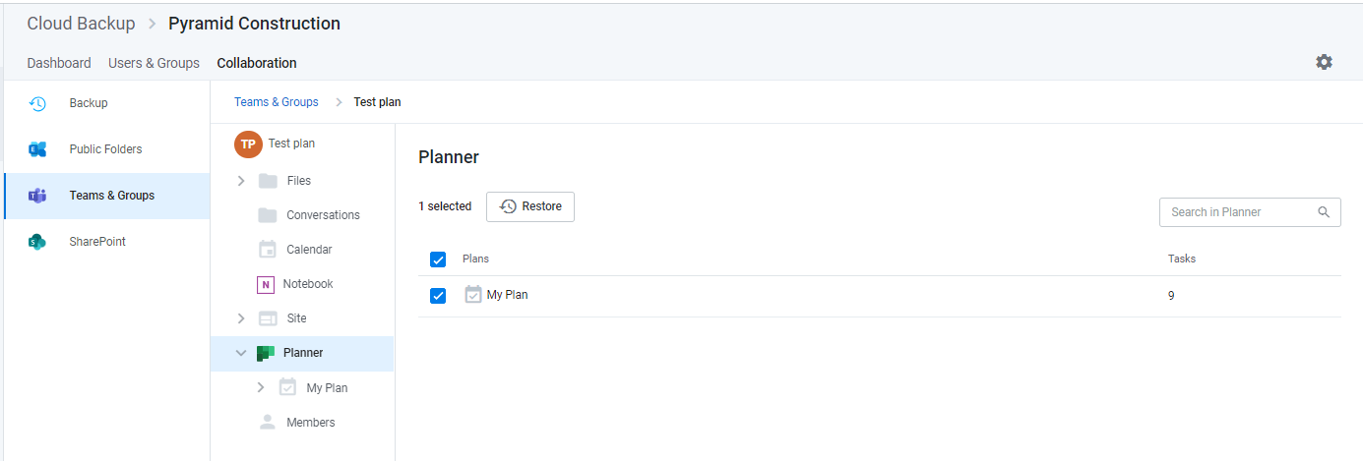
This will initiate the same validation process and Restore button as shown above.

Restore one or more buckets
If you only need to restore one or more buckets of tasks within a plan:
- Select the plan in the left navigation
- Select any number of buckets
- Click the Restore button
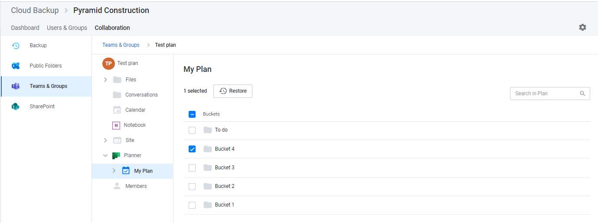
This will initiate the same validation process and Restore button as shown above.

Restore one or more group tasks
If you only need to restore one or more tasks within a bucket:
- Click on the bucket
- Select any number of tasks
- Click the Restore button
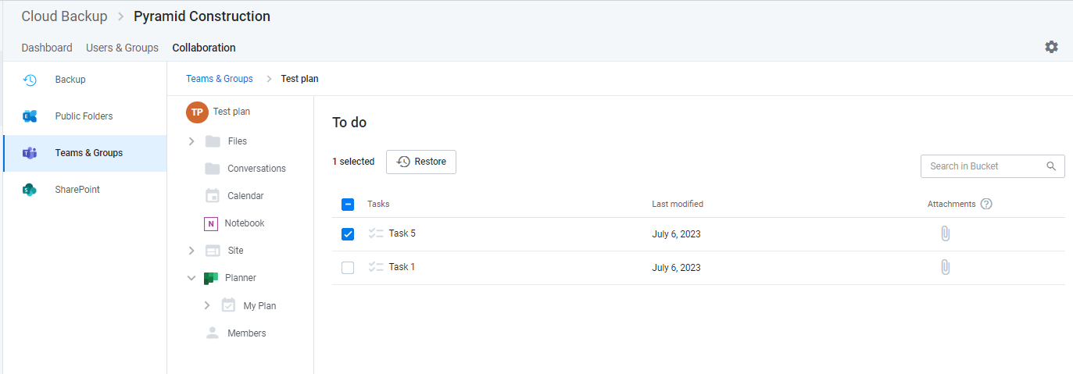
This will initiate the same validation process and Restore button as shown above.

